Basic Security

Default Passwords.

Many IT systems are compromised simply because default passwords were not changed after the system was commissioned. Nutanix Cluster Check provides a check to validate if there are any passwords that are set as default, so you can easily check and action.

1. In Prism Element select Home > Health.

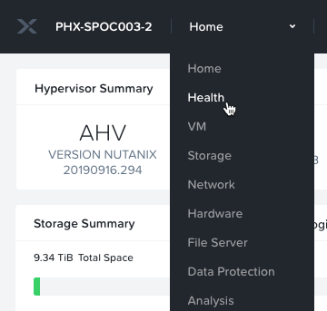

1. On the upper right of the Health page, select **Actions** > **Run NCC Checks.**

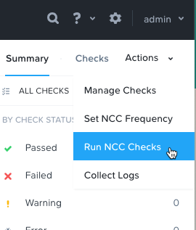

1. In the **Run Checks** box, click **Specified Checks**, and search for **default**. Select one of the **default password** options.

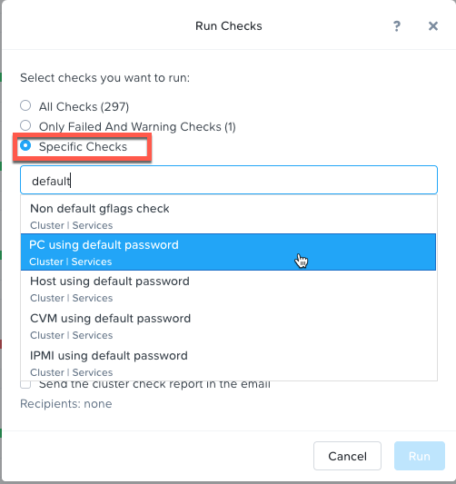

1. Repeat step 3 until all default password checks are included.

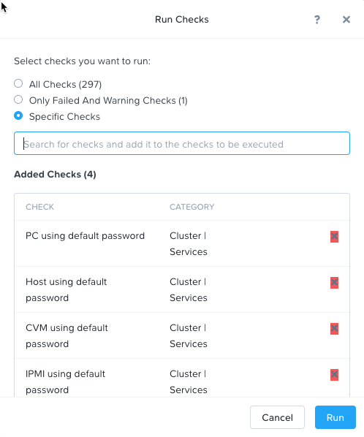

1. Click **Run**
2. To monitor the process, click on the **Tasks** icon in the main bar, and click on **View All Tasks**.

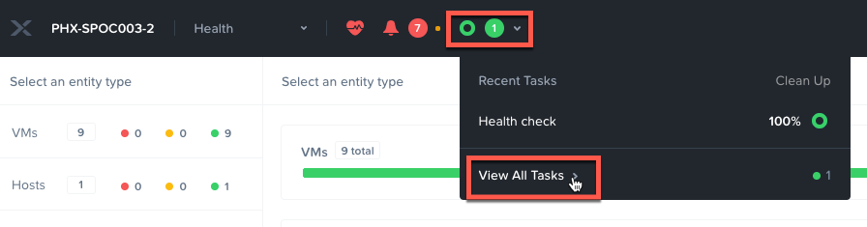

1. Once the **Health Check** has completed, click on **Succeeded** in the Status column.

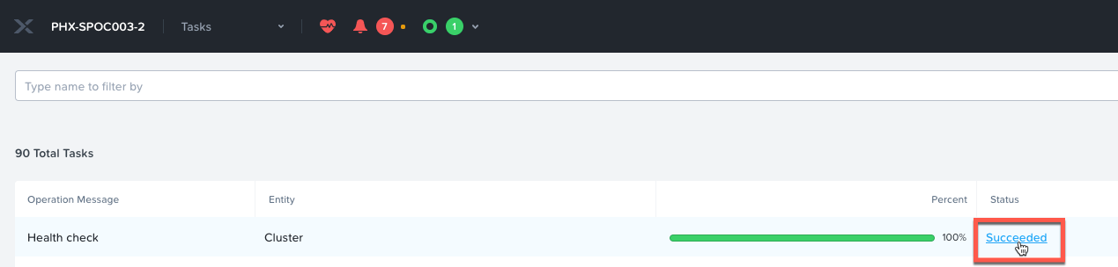

1. From the View Summary page, we can see the 3 checks passed and we have an informational alert on one. Click on **Download Output** to retrieve the report and see the details.

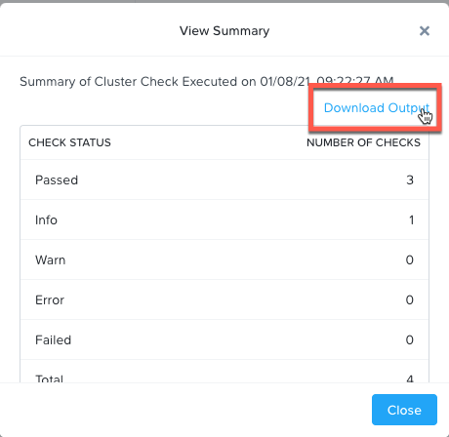

1. Open the downloaded file and review the results.

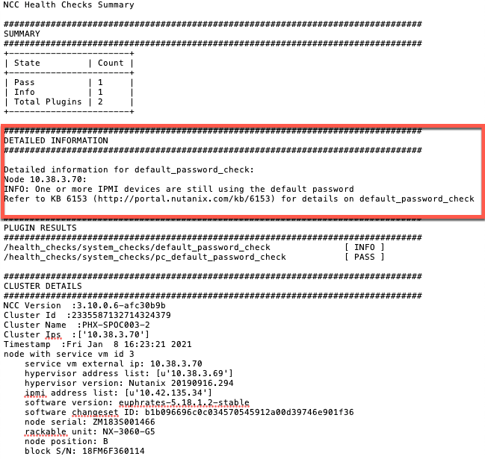

In this example we can see that there is a default password on the IPMI device(s). Due to the HPOC environment, we are not permitted to change the IPMI passwords from the defaults. This finding is expected in this case, but what if there had been default passwords found on the CVM?

Change the default passwords!

It goes without saying, but we’re going to say it anyway, one of the first things that should be done on a newly deployed system is to change the passwords used to install.

1. Prism Central > **Virtual Infrastructure**>**VMs**
2. Check the box next to **WinTools** vm > **Actions > Launch Console**

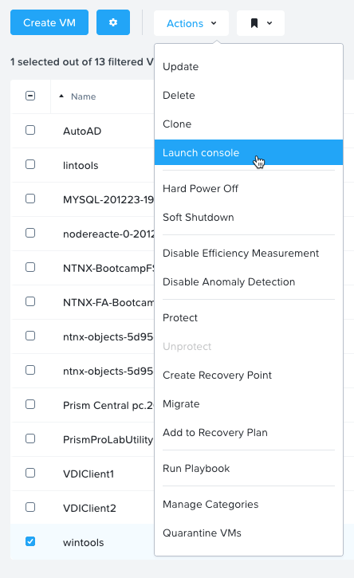

1. Login in as **administrator** with a password of **nutanix/4u**
2. Launch **PuTTy**

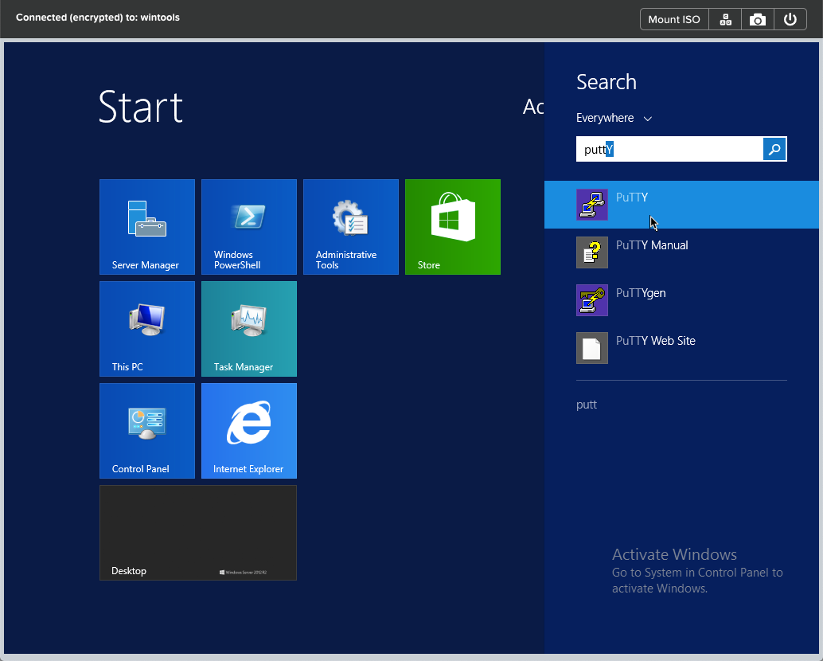

1. Enter the **IP address** of your CVM (from the lab information sheet)
2. Accept the security alert.
3. Logon as **admin** with the password provided in the lab information sheet.

There are 2 system accounts within AOS which have default passwords after cluster initialization: **nutanix** and **root**. To change these, issue the following commands, providing the admin password when prompted.

1. For the **nutanix** account:

sudo passwd nutanix

1. For the **root** account:

sudo passwd root

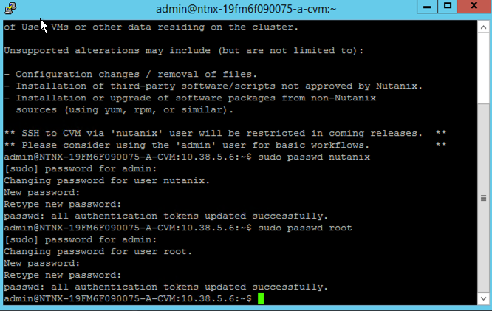

Note: This only changes the passwords on a single CVM, if you add allssh to the above commands, it will change the passwords on ALL CVMs in the cluster.

Custom Banner

Login banners provide a definitive warning to any possible intruders that may want to access your system that certain types of activity are illegal, but at the same time, it also advises the authorized and legitimate users of their obligations relating to acceptable use of the computerized or networked environment(s).

1. Prism Element > **Settings** > **Welcome Banner**

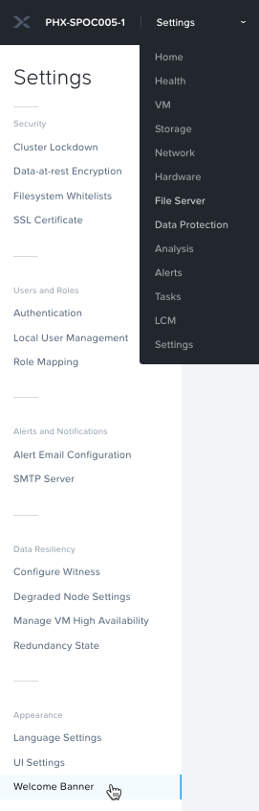

1. Enter your text into the black area (you can use HTML to mark up the text).

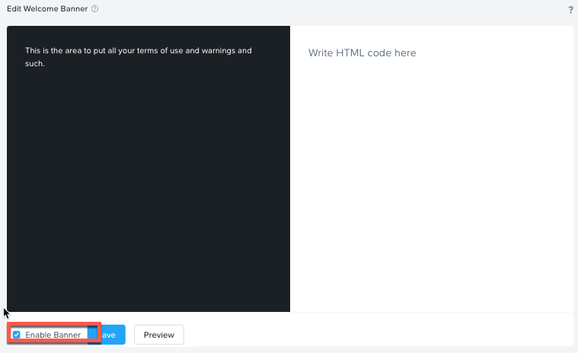

1. Check **Enable Banner**
2. Click **Save**
3. Sign out of Prism Element.

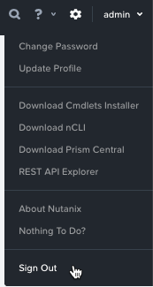

1. Now before seeing a login prompt, the banner is displayed, and must be accepted to login.

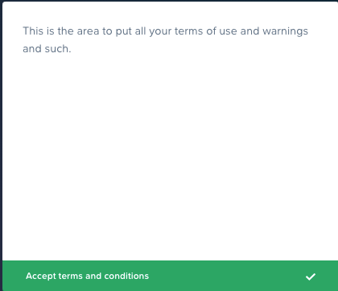

NOTE: This procedure also is applicable for Prism Central.

Platform Security and Hardening

The Nutanix platform (AOS and AHV) include several security features natively. These include:

* Advanced Intrusion Detection Environment (AIDE)
* Core - Generates stack traces when there's an issue or SCMA is unable to remediate.
* High Strength Passwords (Min Length = 15, Difference of previous = 8, remember previous = 24)
* Banner – Presents an informational banner upon login to the CVM.
* SNMPv3 Only – Forces use of SNMPv3 instead of v2
* SCMA schedule – Nutanix has implemented security configuration management automation (SCMA) to check multiple security entities (STIG) for both Nutanix storage and AHV. Nutanix automatically reports log inconsistencies and reverts them to the baseline.

To view the current configuration:

1. Prism Central  > **Virtual Infrastructure** >**VMs**
2. Check the box next to **WinTools** vm > **Actions** > **Launch Console**



1. Login in as **administrator** with a password of **nutanix/4u.**
2. Launch PuTTy



1. Enter the IP address of your CVM (from the lab information sheet)
2. Accept the security alert
3. Logon as **admin** with the password from the lab information sheet.
4. Enter the following command on the CVM to view settings for these security settings.

ncli cluster get-cvm-security-config

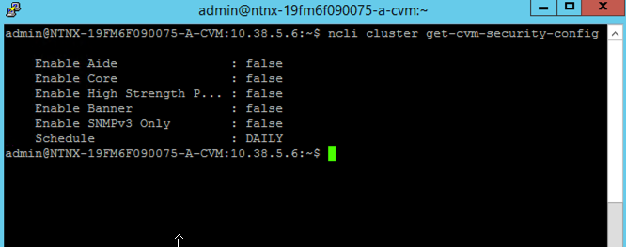

Note: These settings are for the CVM only, the hypervisor maybe configured differently. Please refer to security documentation from your hypervisor vendor for more information.

1. To view these settings on AHV, issue following command:

ncli cluster get-hypervisor-security-config

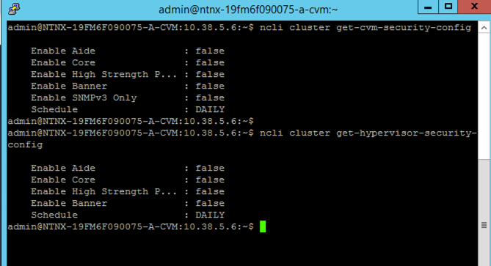

Note that everything is disabled by default, and the SCMA schedule is set to run daily.

Let’s enable AIDE and change the schedule SCMA to scan the system on an hourly basis.

1. At the CVM ssh prompt, enter the following commands:

ncli cluster edit-cvm-security-params enable-aide=true

ncli cluster edit-cvm-security-params schedule=HOURLY

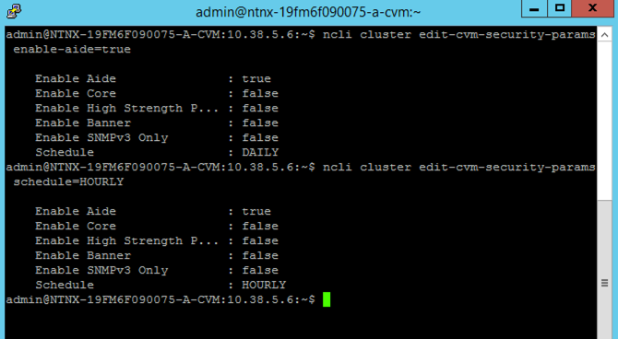

NOTE: Core should only be should only be enabled on direction of Nutanix Support.

Cluster Lockdown

To further enhances your security posture of your Nutanix environment you can enable cluster lockdown. When in lockdown, password-based CVM access is disabled, and only key based access is allowed.

First, we need to generate public and private keys.

1. On your **WinTools** vm, open PuTTYgen

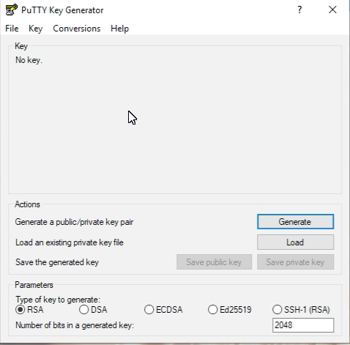

1. Click Generate and move the mouse randomly in the blank area until the key is generated.

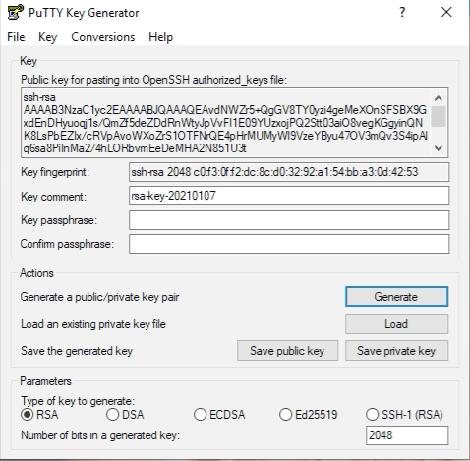

1. Click **Save private key**, and save it to the desktop as ***intials*-Key.ppk** (adding a .ppk extension). Click **Yes** to save without a passphrase.

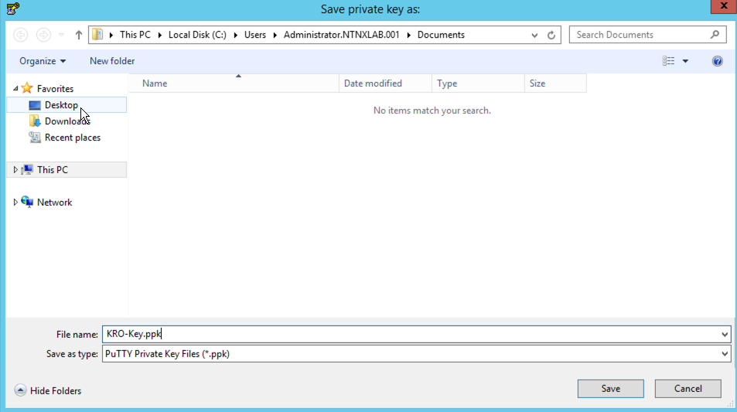

1. Click **Save public key**, and save it to the desktop as ***intials*-Key.pub** (adding a .pub extension).

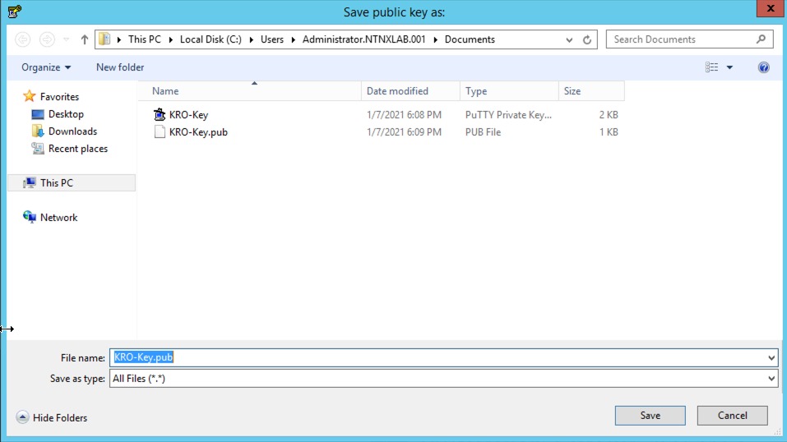

1. **Select** and **copy** the public key from the Key window in PuTTYgen.

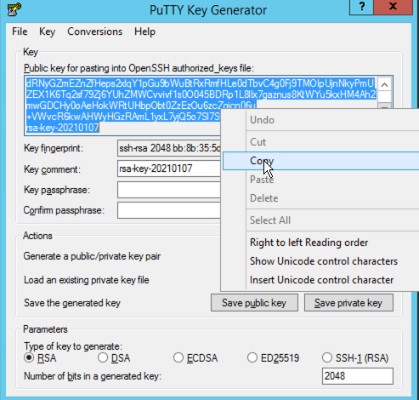

1. In Prism Element, click Home > Settings. In the Settings menu on the left side scroll down to Security and click on Cluster Lockdown.

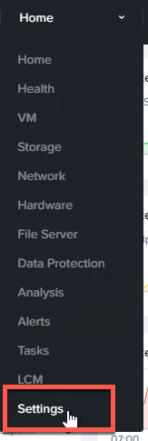 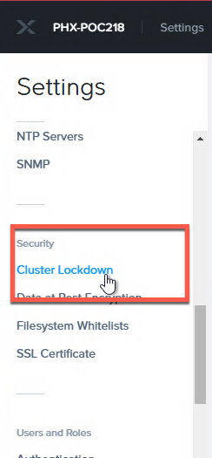

1. Click + New Public Key and complete as follows:

* Name: ***intitals*-Key**
* Key – Paste the key string you previously copied in step 5.

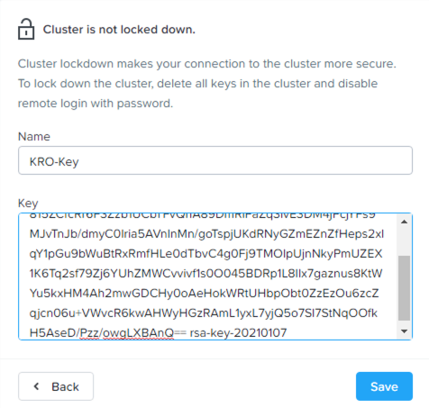

Assure the key begins with “ssh-rsa” and ends with “rsa-key-xxxxxxxx” (where xxxxxxxx is the creation date of the key. This means the complete key has been inserted.

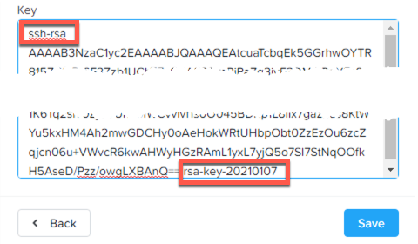

1. Click Save and now your key is saved to the cluster.
2. Uncheck Enable Remote Login with Password.

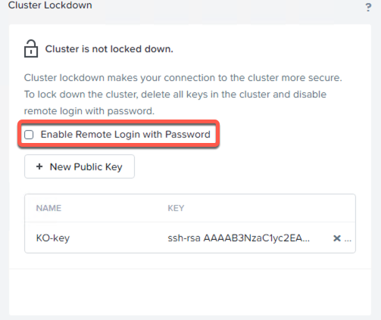

1. On your WinTools vm, open PuTTY.
2. Enter the Prism Element (CVM) IP address.

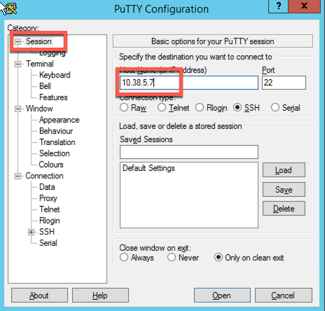

1. In the **Connection** section, click on **Data**, and enter **nutanix** in the **Auto-login username** box.

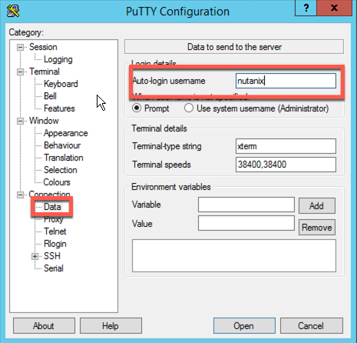

1. Expand the **SSH** section, and click on **Auth**, click browse and add the ***intials*-Key.ppk**, you saved to the desktop in step 3.

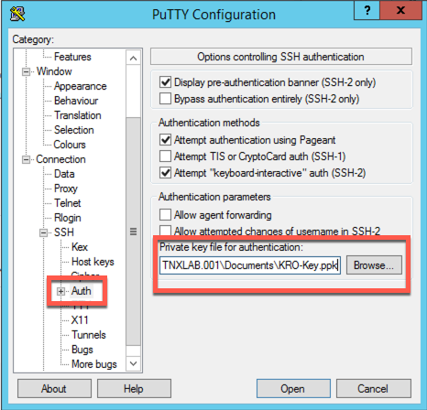

1. Click **Open**, and the login will be completed without the prompt for userid or password.

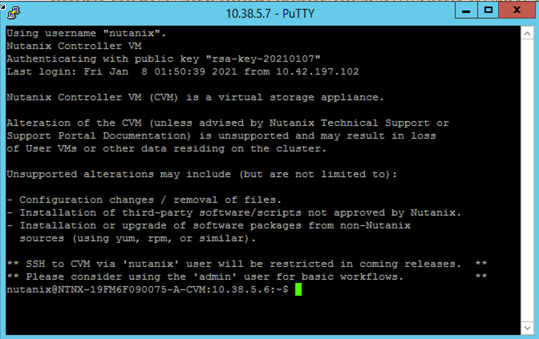

1. To validate that password based login is unavailable, right click on the top bar of the current PuTTY window, and select **New Session**.

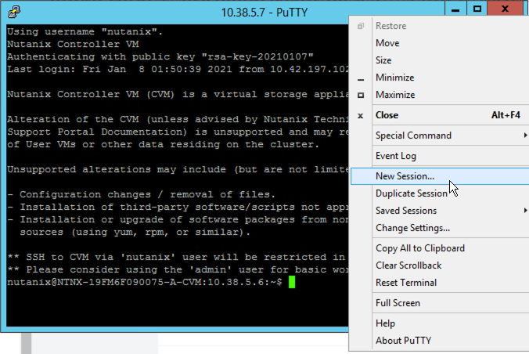

1. Enter your Prism Element (CVM) IP, and click **Open**.

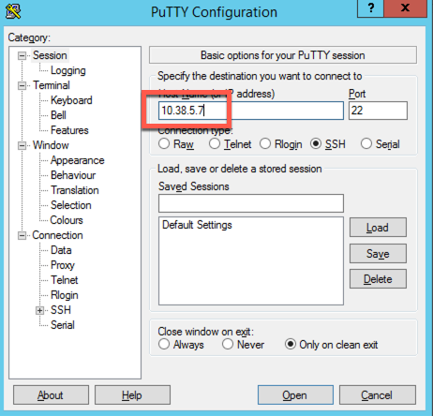

1. At the login prompt, enter **nutanix**, and press enter.

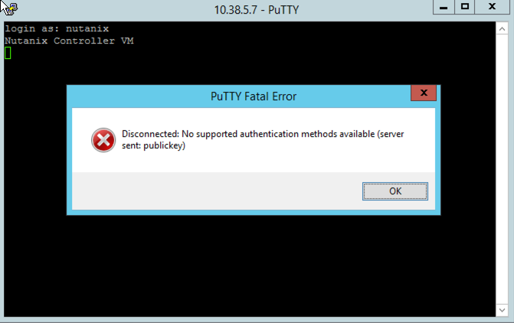

Note that the session is immediately disconnected, without any additional prompts.

This procedure is also applicable for Prism Central.

**Security Technical Implementation Guide (STIG)**

## Working with Nutanix STIGs

Nutanix also provides administrators with Security Technical Implementation Guides (STIGs), which are security tools encoded in a machine-readable format to facilitate automated validation, ongoing monitoring, and self-remediation. These reduce the time required to verify security compliance from weeks or months to days without slowing down product evolution. STIGs are based on well-established standards by National Institute of Standards and Technology (NIST) that can apply to multiple baseline requirements for DoD and PCI-DSS. However, Nutanix STIGs are specific to the Acropolis platform and therefore more effective.

In this lab you will see STIGs in action in order to see first-hand how they harden the Nutanix Enterprise Cloud OS and help reduce zero-day vulnerabilities.

**Note**

Nutanix AOS and AHV STIGs can be downloaded [here](https://portal.nutanix.com/#/page/static/stigs) from the Nutanix Portal.

### Running a STIG Report

Follow the exercise below to manually run a STIG report on your Nutanix cluster. By default, these checks run on a Nutanix cluster once every 24 hours, whereas in a typical legacy infrastructure environment, STIGs would be applied manually at the time of deployment and have no automated means of ensuring the original configuration is unchanged over time.

1. Connect to Controller VM (CVM) as admin user via SSH (Using Terminal, putty, or similar program)
2. Change to the root directory of the CVM, and list the files available to the root user to execute within the /root directory.

cd /

sudo ls -l root

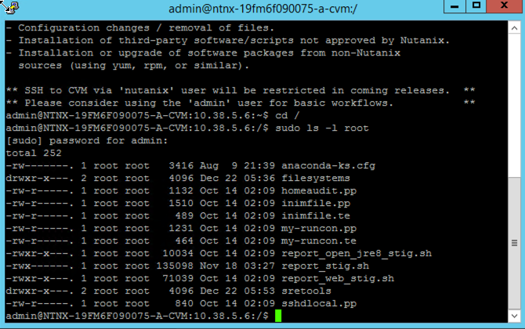

There should be three .sh files that end in _stig.sh and you’ll want to run the one that outputs the report in the format you prefer.

1. In this example, we’ll run the generic text output “report_stig.sh”

sudo /root/report_stig.sh

Note: This takes ~1 minute to complete.

1. As indicated, the report is saved to /home/log/STIG-report-xx-xx-xxxx-xx-xx-xx (where the xx’s are the date/time the report was created).

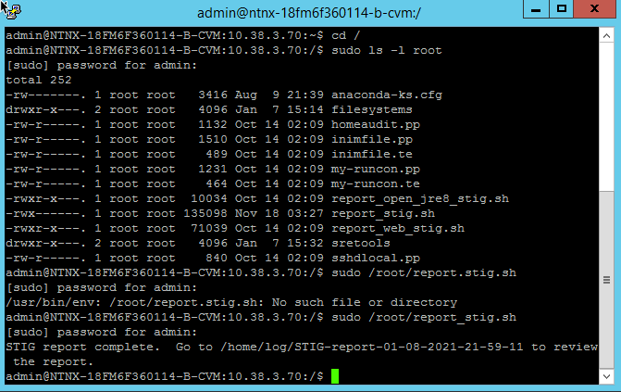

1. List the files in the folder and note the name of the report.

sudo ls -l /home/log | grep STIG

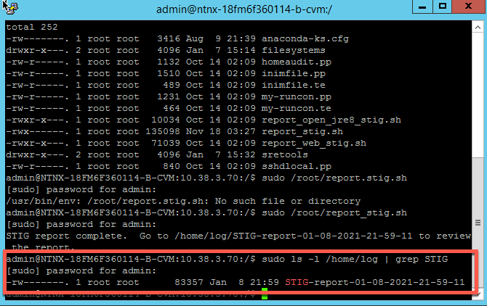

1. Copy the report to the admin home directory, substituting the actual file name for the asterisks.

sudo cp /home/log/STIG-report-**-**-****-**-**-** /home/admin

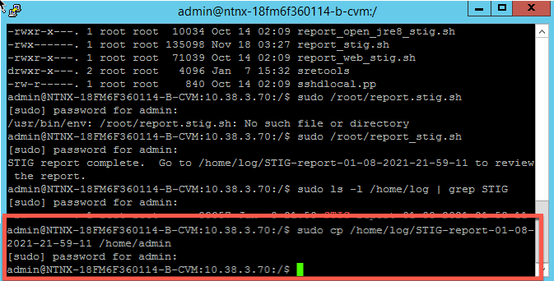

1. Change to the admin home directory and list the files.

cd

ls -l

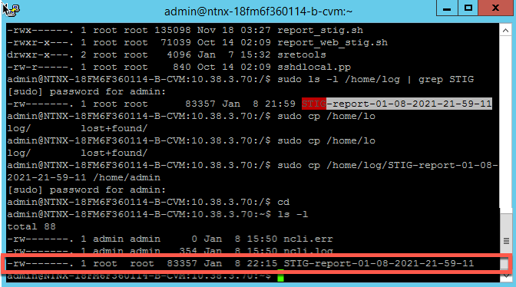

Note that the report file is only readable by root, so we’ll change the ownership.

1. To change the file ownership to admin, enter the following command, replacing the asterisks with your actual file name:

sudo chown admin:admin /home/admin/STIG-report-**-**-****-**-**-**

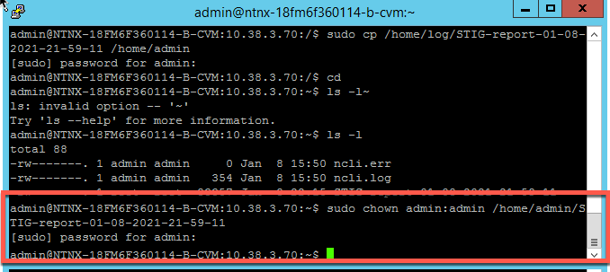

From your WinTools vm, use a secure copy tool (SCP, WINSCP, PSCP, etc) to copy the report results file to your workstation from the CVM. Alternatively you can open and view the text file in your SSH session using vi, more, cat, etc.

1. Open WinSCP, set the **File Protocol** to **SCP,** enter the CVM IP address, admin for the User Name and the assigned password.

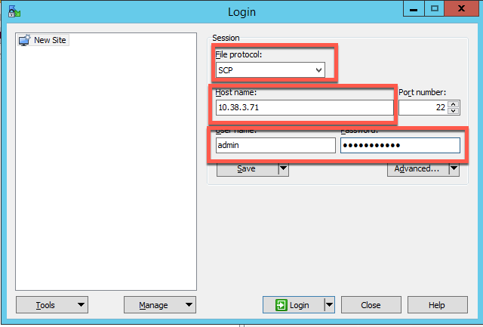

1. Change the local directory to **Desktop**

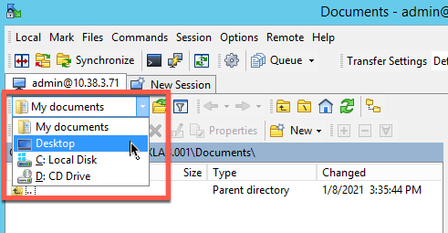

1. Drag the STIG report from the CVM (right pane) to the local desktop (left pane)

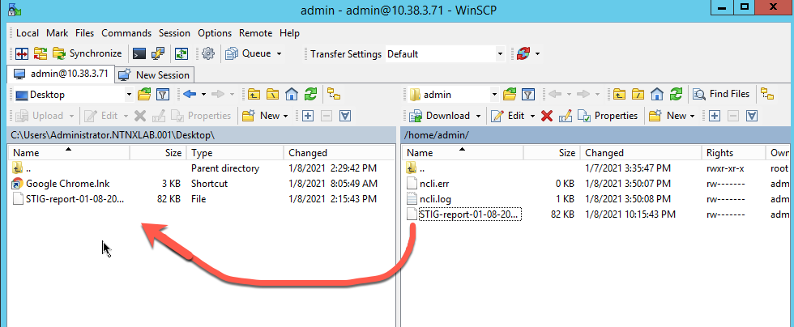

1. From the desktop, open the STIG report – use Chrome or Sublime, it does not format well with NotePad.

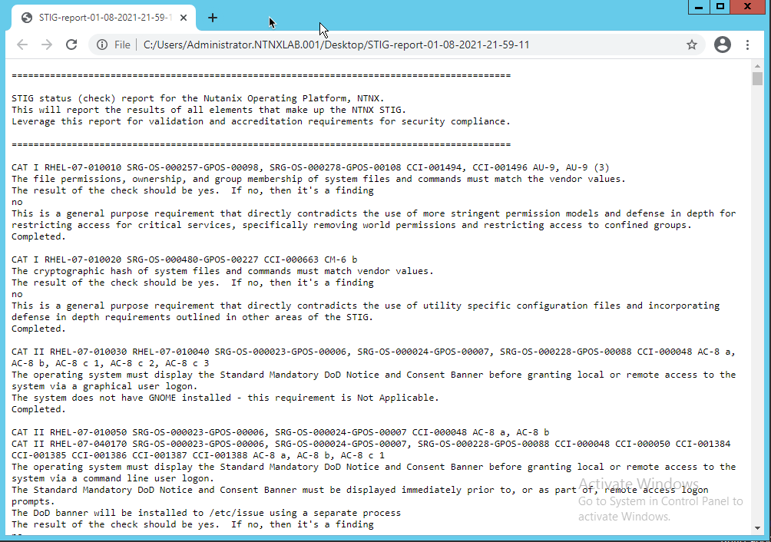

**Analyzing the STIG Report**

The STIG report can be used for validation and accreditation requirements for security compliance.

The format of each result within the report is as follows:

**Line 1** - Check name

**Line 2** - Description of the check

**Line 3** - Legend, or expected result of the check

**Line 4** - Check result

**Line 5** - Completion status of the check

Below is an example of a non-finding in the STIG report, meaning that the check did not discover an unwanted configuration:

CAT II RHEL-07-021030 SRG-OS-000480-GPOS-00227 CCI-000366 CM-5 (1)

All world-writable directories must be group-owned by root, sys, bin, **or** an application group.

The result of the check should be yes. If no, then it's a finding

yes

Completed.

And an example of a finding, where the check was found to have an unwanted configuration:

CAT I RHEL-07-021710 SRG-OS-000095-GPOS-00049 CCI-000381 CM-7 a, CM-7 b

The telnet-server package must **not** be installed.

The result of the check should be yes. If no, then it's a finding

no

Completed.

SCMA (Security Configuration Management Automation)

In this exercise you will embrace your inner dark side and compromise the security of the cluster by making non-compliant changes - and you would have gotten away with it too, if it weren’t for you pesky STIGs (*any Scooby Doo fans in the audience? No? OK just me then, fine.*).

Since this lab exercise will generate more output than can be stored in the screen buffer, we will want to log all the output to a log file for review.

1. On your **Wintools** vm, open **PuTTY**, and click on **Session** -> **Logging** in the Putty configuration window. Under Session logging: check “**All session output**”, and for the “**Log file name**”, click **Browse** and select the Desktop (for easy access).

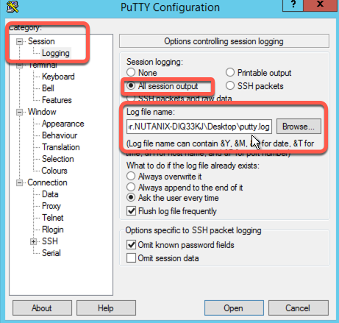

1. Click on Session in the left column, connect to your cluster IP, and login as admin with the password provided.

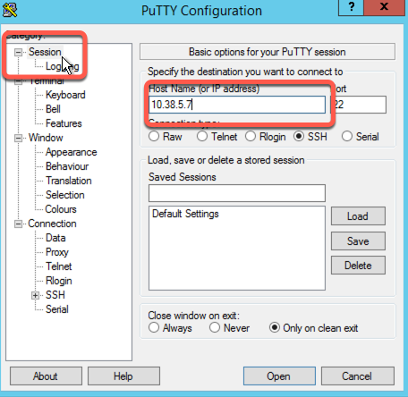

1. At the prompt, enter the command:

sudo salt-call state.highstate

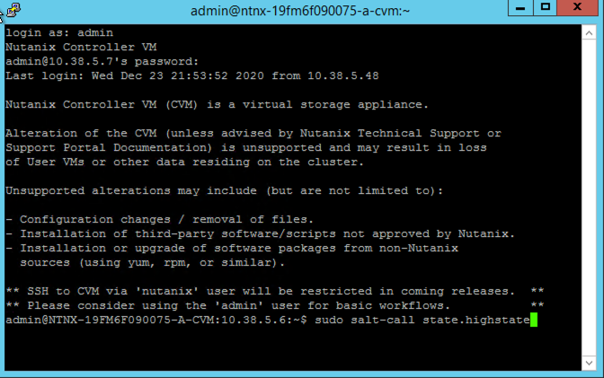

Enter the admin password when prompted.

1. After the execution completes (takes about a minute), open the putty file on the desktop with Notepad, and search for “**resolv.conf**”.

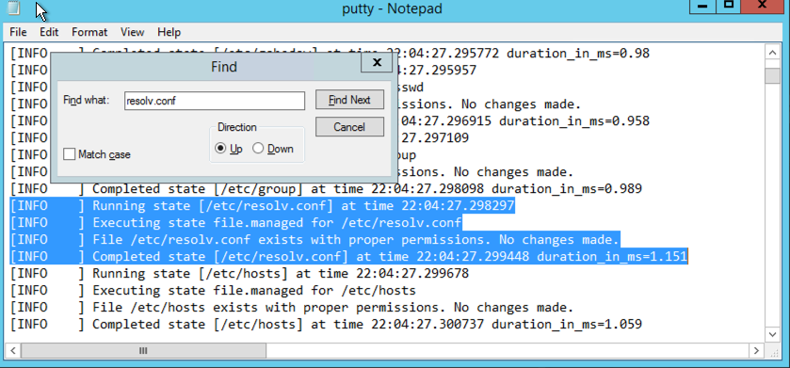

Note that no change was made.

1. Close Notepad.

Now we’ll “compromise” the system.

1. In the putty session, enter the below command and provide the admin password when prompted.

sudo chmod 755 /etc/resolv.conf

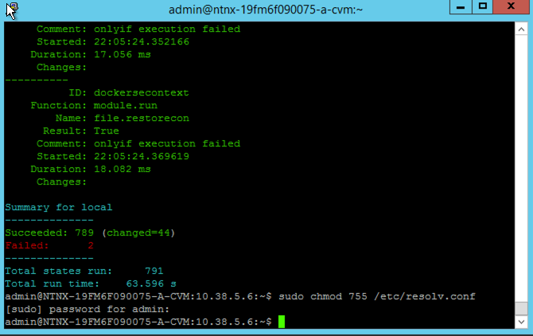

1. Rerun the salt-call command and provide admin password when prompted. Wait until the execution completes (again, about a minute)

sudo salt-call state.highstate

1. Open the putty file in Notepad again, and this time search for “***Executing state file.managed for /etc/resolv.conf***”. You want to find the 2nd instance of this string.

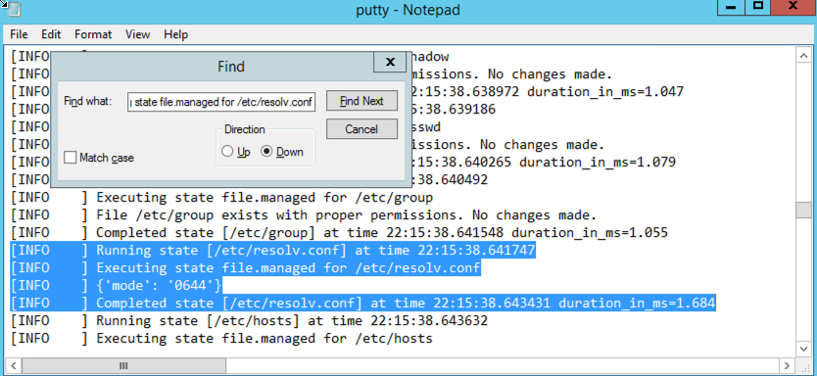

Note the file permissions (mode) have been changed from the 755 we set them to, back to the 644 as specified in the STIG.

1. Close Notepad.

Let’s do another example, this time we will edit the sshd configuration file to permit root login, which should be noted, is very much **against all security best practices, and should NEVER be done in a production environment.**

1. In putty, at the prompt, enter the command:

sudo nano /etc/ssh/sshd_config

(feel free to use the editor of your choice)

1. Once the file is opened for editing, search for **PermitRoot** – (CTRL-W to search in nano) and change the **no** to **yes**.

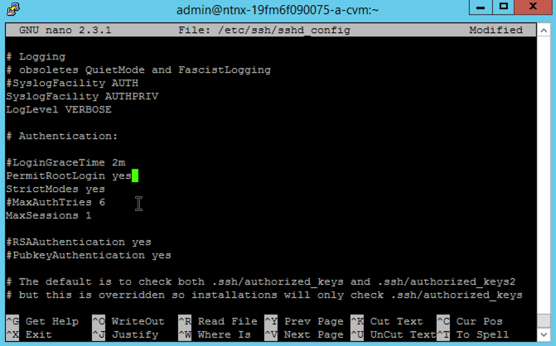

CTRL-O to save the file, and CTRL-X to exit nano.

1. Now run the command:

sudo salt-call state.highstate

Provide admin password when prompted and wait until the execution completes (again, about a minute)

1. Upon completion, open the putty log file and search for **PermitRootLogin**

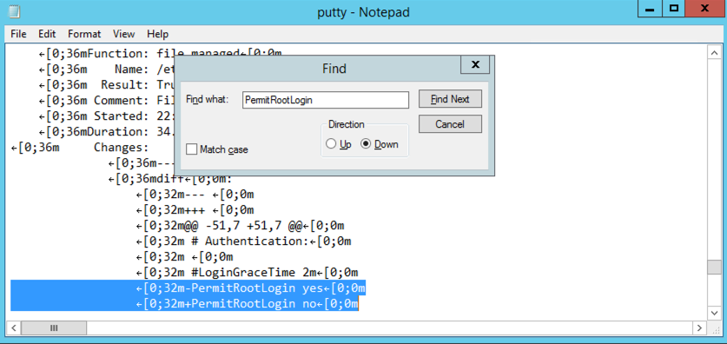

Note the **PermitRootLogin yes** is preceded by a **-** sign indicating it was removed from the file, while **PermitRootLogin no** is preceded by a **+** sign indicating it was added, restoring the file to the parameter as defined by the STIG.

SECURING APPLICATIONS WITH FLOW

Flow is an application-centric network security product tightly integrated into Nutanix AHV and Prism Central. Flow provides rich network traffic visualization, automation, and security for VMs running on AHV.

Microsegmentation is a component of Flow that uses simple policy-based management to secure VM networking. Using Prism Central categories (logical groups), you can create a powerful distributed firewall. Combining this with Calm allows automated deployment of applications that are secured as they are created.

**In this exercise you will restrict access to the Fiesta application and protect traffic between the application tiers.**

Securing the Fiesta Application

Flow provides multiple System categories out of the box, such as AppType, AppTier, and Environment, that are used to quickly group virtual machines. Security policies are applied using these categories. You can start using these pre-existing categories right away, or add your own categories for custom grouping.

**Defining Category Values**

Prism Central uses categories as metadata to tag VMs to determine how policies will be applied.

1. In **Prism Central**, select  **> Virtual Infrastructure > Categories**.

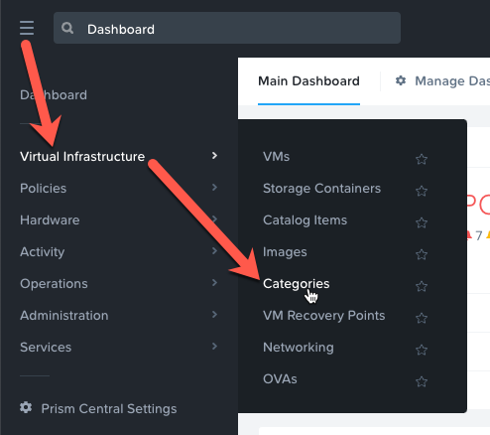

1. Select the checkbox for **AppType** and click **Actions > Update**.

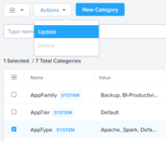

1. Click the icon beside the last value to add an additional Category value.
2. Specify *Initials*-**Fiesta** as the value name.

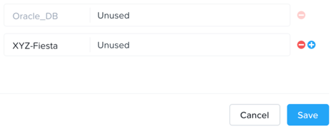

1. Click **Save**.
2. Select the checkbox for **AppTier** and click **Actions > Update**.
3. Click the  icon beside the last value to add an additional Category value.
4. Specify *Initials*-**Web** as the value name. This category will be applied to the application’s web tier.
5. Click  and specify *Initials*-**DB**. This category will be applied to the application’s MySQL database tier.

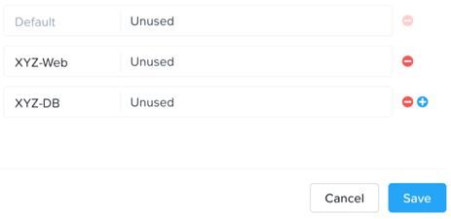

1. Click **Save**.

**Creating a Security Policy**

Nutanix Flow includes a policy-driven security framework that uses a workload-centric approach instead of a network-centric approach. Therefore, it can scrutinize traffic to and from VMs no matter how their network configurations change and where they reside in the data center. The workload-centric, network-agnostic approach also enables the virtualization team to implement these security policies without having to rely on network security teams.

Security policies are applied to categories and not to the VMs themselves. Therefore, it does not matter how many VMs are started up in a given category. Traffic associated with the VMs in a category is secured without administrative intervention, at any scale.

Create the security policies that will protect the Fiesta application.

1. In **Prism Central**, select  **> Policies > Security**.

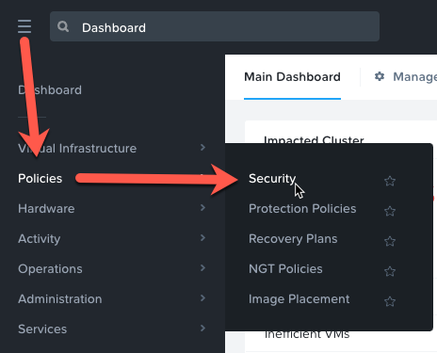

1. Click **Create Security Policy > Secure Applications (App Policy) > Create**.
2. Fill out the following fields:
   * **Name** - *Initials*-Fiesta
   * **Purpose** - Restrict unnecessary access to Fiesta
   * **Secure this app** - AppType: *Initials*-Fiesta
   * Do **NOT** select **Filter the app type by category**.

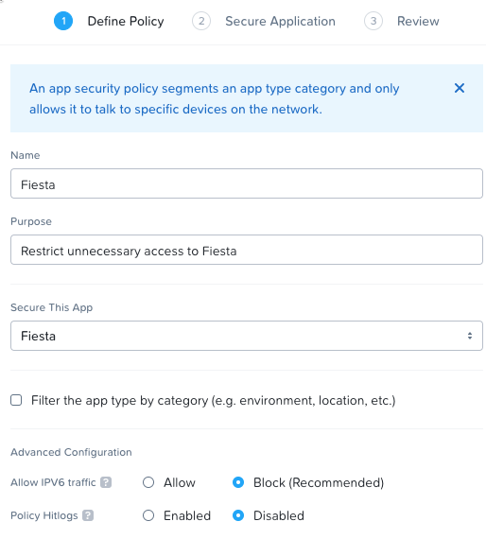

1. Click **Next**.
2. If prompted, click **OK, Got it!** on the tutorial diagram of the **Create App Security Policy** wizard.
3. To allow for more granular configuration of the security policy, click **Set rules on App Tiers, instead** rather than applying the same rules to all components of the application.

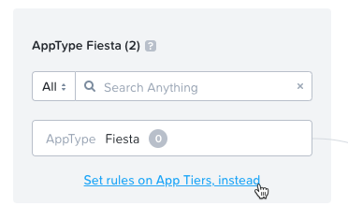

1. Click **Select a Tier to add**.
2. Select **AppTier:***Initials*-**Web** from the drop down.
3. Repeat Steps 7-8 for **AppTier:***Initials*-**DB**.

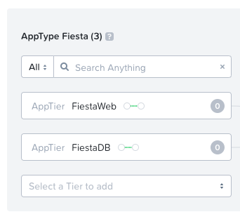

Next you will define the **Inbound** rules, which control which sources you will allow to communicate with your application. You can allow all inbound traffic, or define whitelisted sources. By default, the security policy is set to deny all incoming traffic.

In this scenario we want to allow inbound TCP traffic to the web tier on TCP port 80 from all clients.

1. Under **Inbound**, click **+ Add Source**.
2. Fill out the following fields to allow all inbound IP addresses:
   * **Add source by:** - Select **Subnet/IP**
   * Specify **0.0.0.0/0**
   * Click **Add**

**Note**

Sources can also be specified by Categories, allowing for greater flexibility as this data can follow a VM regardless of changes to its network location.

1. To create an inbound rule, select the **+** icon that appears to the left of **AppTier:***Initials*-**Web**.

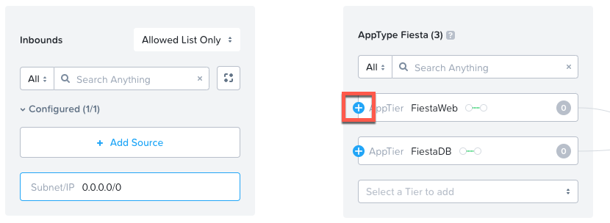

1. Click on **Select a Service**
2. In the Service Table, click Search for a service and enter “http”, and select http from the list.

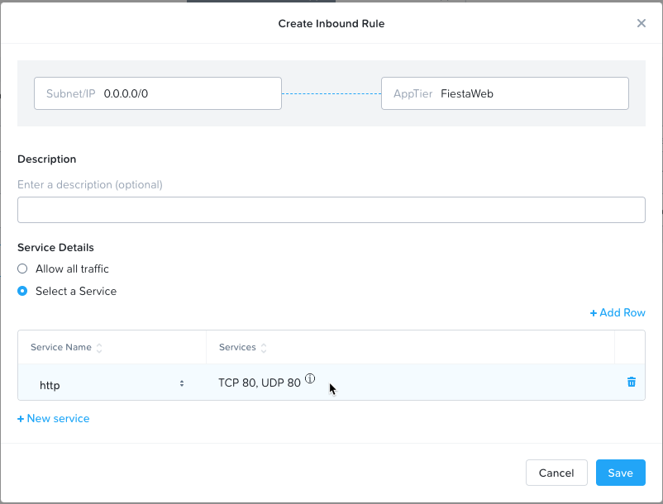

**Note**

Multiple services (protocols and ports) can be added to a single rule.

1. Click **Save**.
2. Under **Inbound**, click **+ Add Source**.
3. Fill out the following fields:
   * **Add source by:** - Select **Subnet/IP**
   * Specify *Your Prism Central IP*/32

**Note**

The **/32** denotes a single IP as opposed to a subnet range.

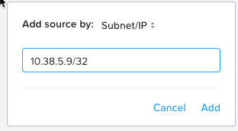

1. Click **Add**.
2. Select the **+** icon that appears to the left of **AppTier:***Initials*-**Web**, click **Select a Service,** enter **ssh** for the Service Name, **Save**.

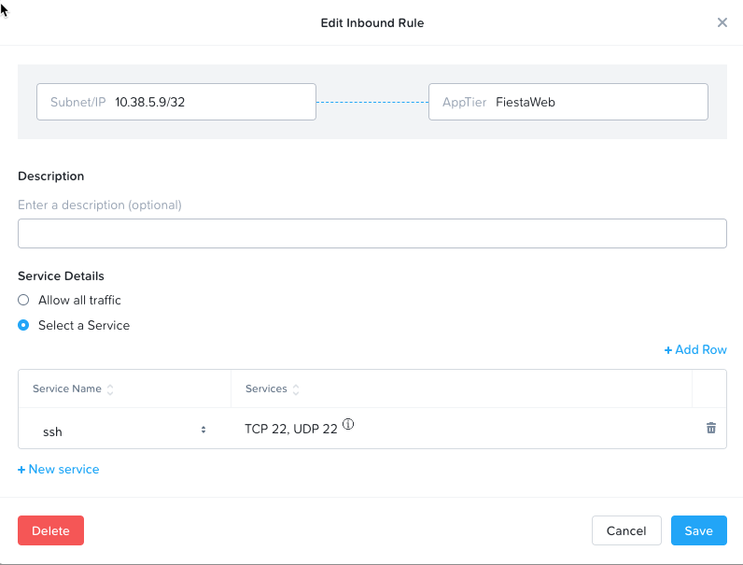

1. Repeat Step 18 for **AppTier:***Initials*-**DB** to allow Calm to communicate with the database VM.

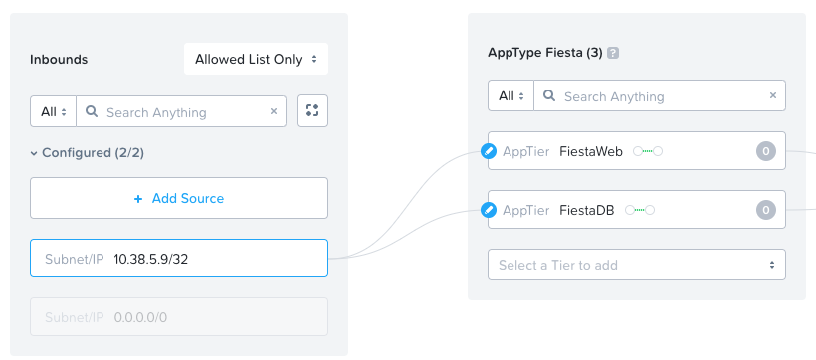

By default, the security policy allows the application to send all outbound traffic to any destination. The only outbound communication required for your application is to communicate with your DNS server.

1. Under **Outbounds**, select **Allowed List Only** from the drop down menu, and click **+ Add Destination**.
2. Fill out the following fields:
   * **Add source by:** - Select **Subnet/IP**
   * Specify *Your Domain Controller IP*/32

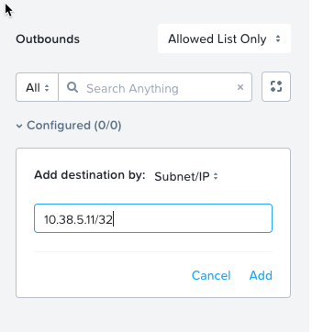

1. Click **Add**.
2. Select the **+** icon that appears to the right of **AppTier:***Initials*-**Web**, click **Select a Service,** enter **domain** for the Service Name, click **Save** to allow DNS traffic.

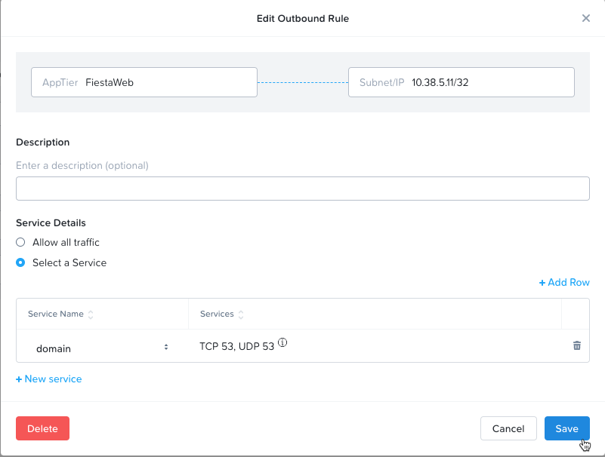

1. Repeat this for **AppTier:***Initials*-**DB**.

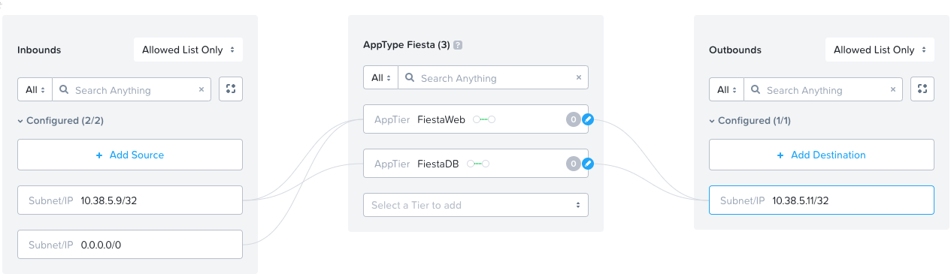

Each tier of the application communicates with other tiers and the policy must allow this traffic. Some tiers such as web do not require communication within the same tier.

1. To define intra-app communication, click **Set Rules within App**.

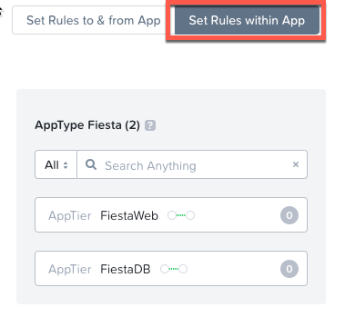

1. Click **Edit**  **AppTier:***Initials*-**Web** and select **No** to prevent communication between VMs in this tier. There is only a single web VM within the tier.

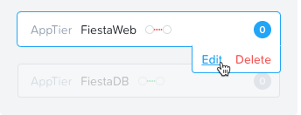 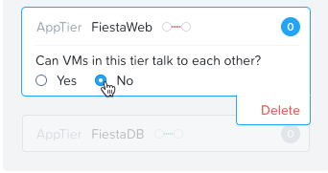

1. While **AppTier:***Initials*-**Web** is still selected, click the  icon to the right of **AppTier:***Initials*-**DB** to create a tier to tier rule.

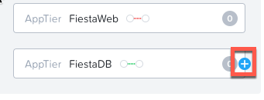

1. Click **Select a Service,** enter **mysql** for the Service Name.

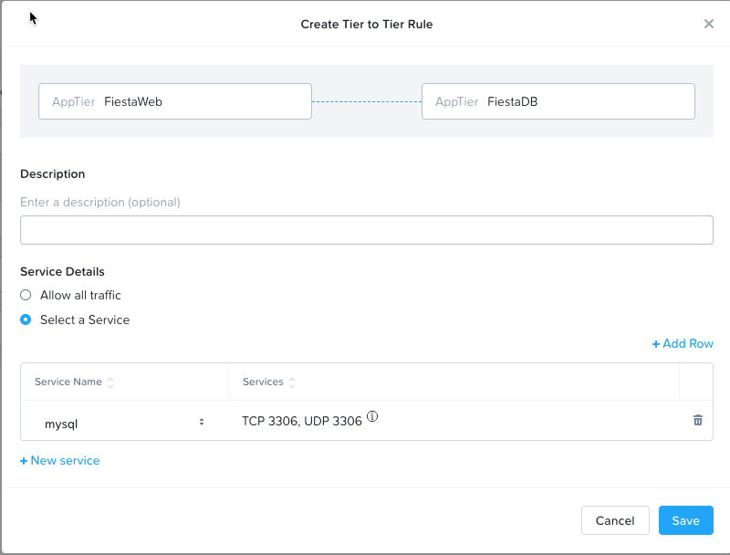

1. Click **Save**.
2. Click **Next** to review the security policy.
3. Click **Save and Monitor** to save the policy.

**Assigning Category Values**

You will now apply the previously created categories to the VMs provisioned from the Fiesta blueprint. Flow categories can be assigned as part of a Calm blueprint, but the purpose of this exercise is to understand category assignment to existing virtual machines.

1. In **Prism Central**, select  **> Virtual Infrastructure > VMs**.
2. Click **Filters** and select the label for *Initials AHV Fiesta VMs* to display your virtual machines.

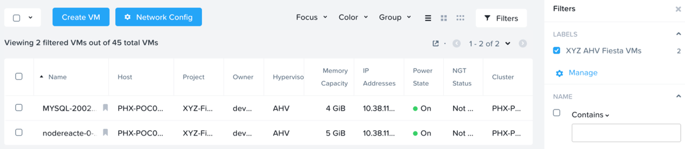

1. Using the checkboxes, select the 2 VMs associated with the application (Web and DB) and select **Actions > Manage Categories**.

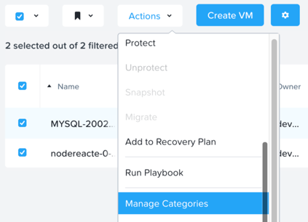

1. Specify **AppType:***Initials*-**Fiesta** in the search bar and click **Save** icon to bulk assign the category to all VMs.

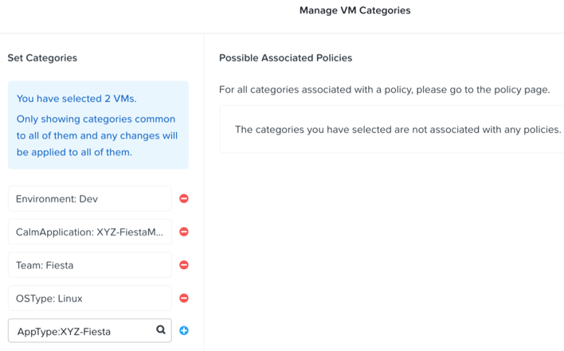

1. Select ONLY the *nodereact* VM, select **Actions > Manage Categories**, specify the **AppTier:***Initials*-**Web** category and click **Save**.

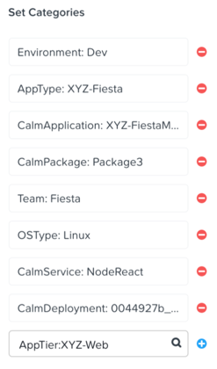

1. Repeat Step 5 to assign **AppTier:***Initials*-**DB** to your MySQL VM.
2. Finally, Repeat step 5 to assign **Environment:Dev** to your Windows Tools VM.

Monitoring and Applying a Security Policy

Before applying the Flow policy, you will ensure the Fiesta application is working as expected.

**Testing the Application**

1. From **Prism Central > Virtual Infrastructure > VMs**, note the IP address of your **nodereacte…** and **-MYSQL-…** VMs.
2. Launch the console for your **WinTools** VM.
3. From the **WinTools** console open a browser and access [http://*node-VM-IP*/](http://node-VM-IP/) (where node-VM-IP is the IP address of your nodereacte vm)
4. Verify that the application loads and that products can be added and deleted.

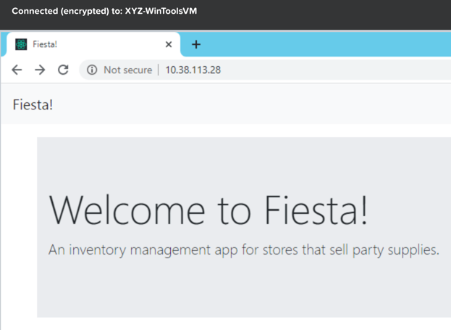

1. Open **Command Prompt** and run ping -t MYSQL-VM-IP to verify connectivity between the client and database. Leave the ping running.
2. Open a second **Command Prompt** and run ping -t node-VM-IP to verify connectivity between the client and web server. Leave the ping running.

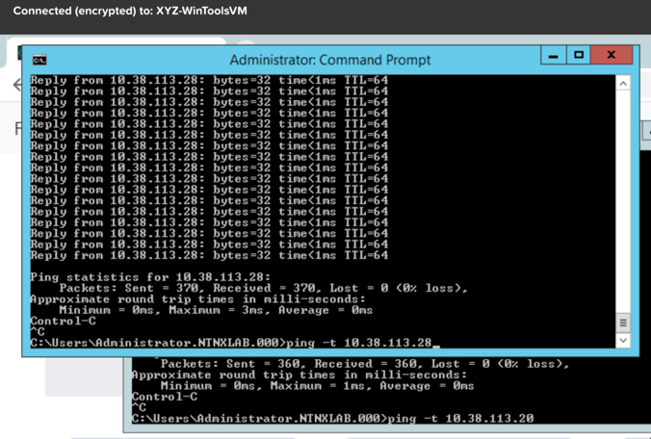

**Using Flow Visualization**

1. Return to **Prism Central** and select  **> Virtual Infrastructure > Policies > Security Policies >***Initials*-**Fiesta**.
2. Verify that your **WinTools** VMappears as an inbound source. The source and line appear in yellow to indicate that traffic that is an exception to the policy has been detected from your client VM.

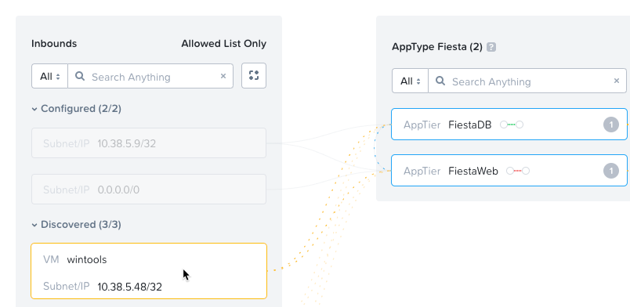

Are there any other detected outbound traffic flows? Hover over these connections and determine what ports are in use.

1. Click **Update** to edit the policy.



1. Click **Next** and wait for the detected traffic flows to populate.
2. Mouse over the **VM**  **Wintools** source that discovered and click **Allow Traffic**.

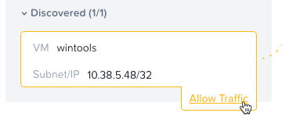

1. Check the boxes next to the discovered traffic you want to permit within the policy. In this case we will permit traffic from our Wintools VM to the web server and block traffic to the DB server. Click **Save**.

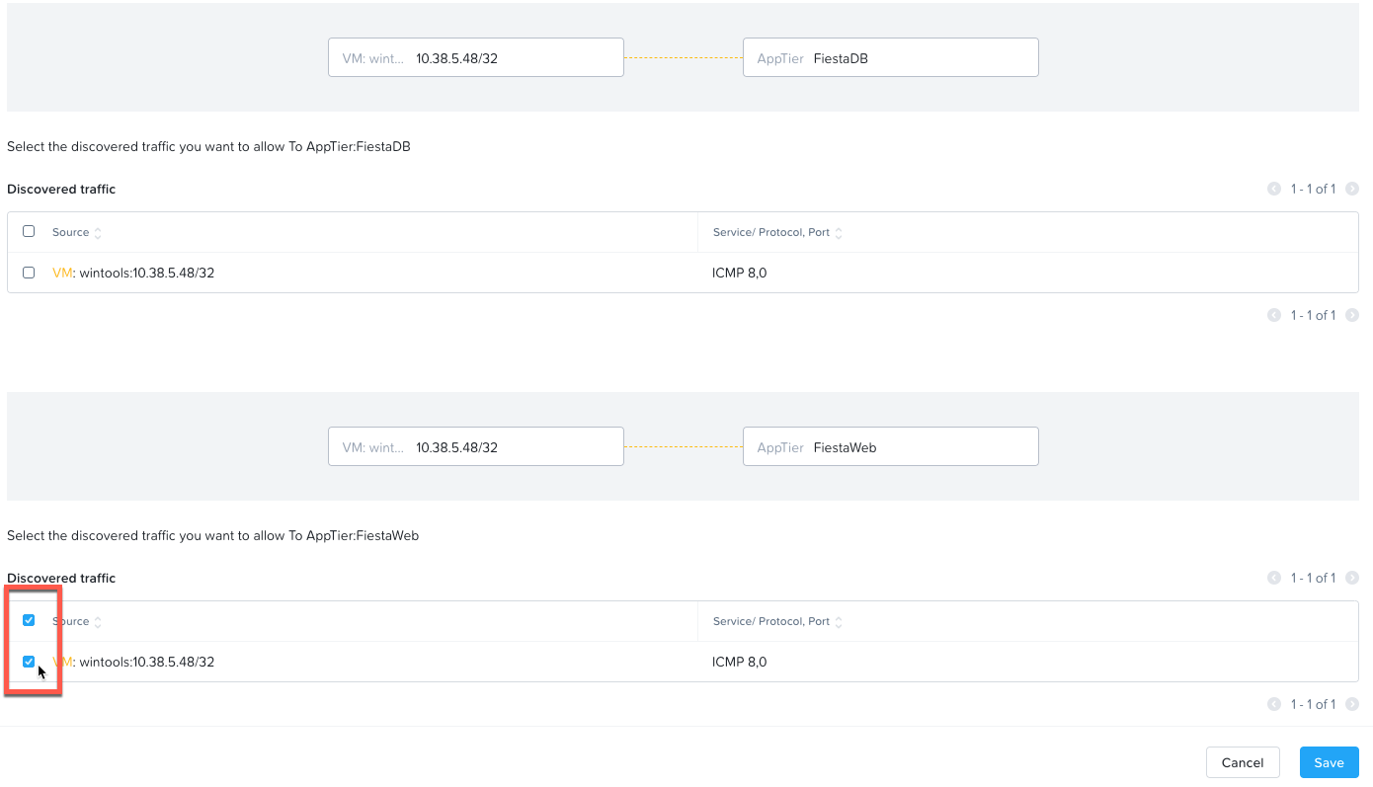

The IP address of your Wintools VM is now added to the permitted inbound list, with a connection to the web server. Mouse over the flow line, and verify the ICMP traffic is allowed. Note that there is still a discovered connection to the DB server. This is because we did not permit this traffic, so it is still showing as an exception to our policy rule.

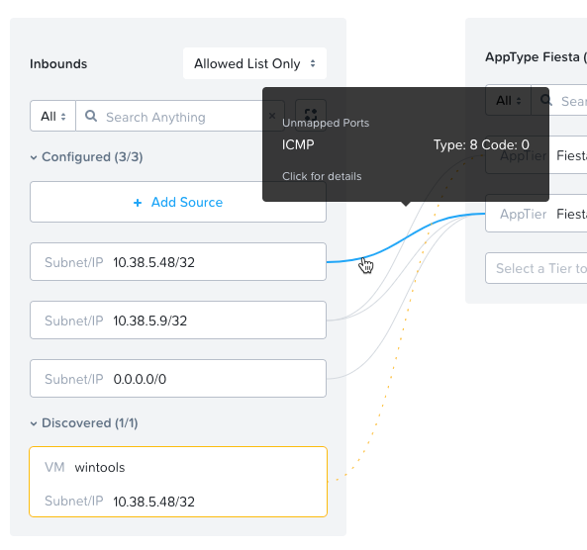

1. Click **Next > Save and Monitor** to update the policy.

**Enforcing Flow Policies**

In order to enforce the policy you have defined, the policy must be enforced.

1. Select *Initials*-**Fiesta** and click **Actions > Enforce**.

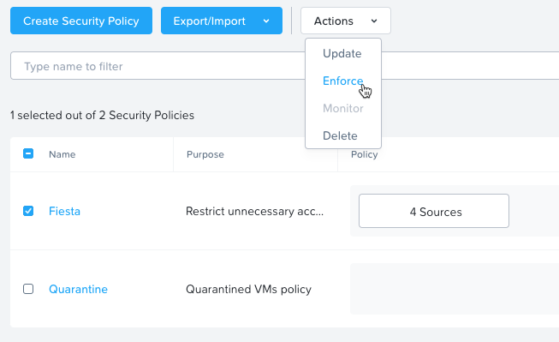

1. Type **ENFORCE** in the confirmation dialogue and click **OK** to begin blocking traffic.
2. Return to the *Initials***-WinToolsVm** console.

What happens to the continuous ping traffic from the Windows client to the database server? Is this traffic blocked?

1. Verify that the Windows Client VM can still access the Fiesta application using the web browser and the web server IP address.

Can you still add new products under **Products** and update product quantities under **Inventory**?

## Takeaways

* Microsegmentation offers additional protection against malicious threats that originate from within the data center and spread laterally, from one machine to another.
* Security policies leverage the text based categories in Prism Central.
* Flow can restrict traffic on certain ports and protocols for VMs running on AHV.
* The policy is created in **Monitor** mode, meaning traffic is not blocked until the policy is enforced. This is helpful to learn the connections and ensure no traffic is blocked unintentionally.

**ID Based Security (VDI Policy)**

ID based firewall integrates Nutanix Flow with Microsoft Active Directory (AD), such that the groups in the AD can be imported into Prism Central as categories. These imported categories can then be used in the VDI policy as target groups, inbound traffic, and outbound traffic. Prism Central automatically places VMs inside the imported AD group categories when user logons are detected on VMs that are part of the Active Directory domain and present on Nutanix managed clusters, thus applying security policies based on user group membership.

First, we have to enable connectivity between Prism Central so that we can import AD user groups for identity based security policies.

NOTE: Some additional configuration is required on the domain controllers to permit this. For the purpose of this lab it has been already completed. Please see the Flow Microsegmentation Guide for further details.

1. In Prism Central, select  > Prism Central Settings.
2. Click **ID Based Security** from the Settings menu (on the left).

The **ID Based Security** page is displayed.

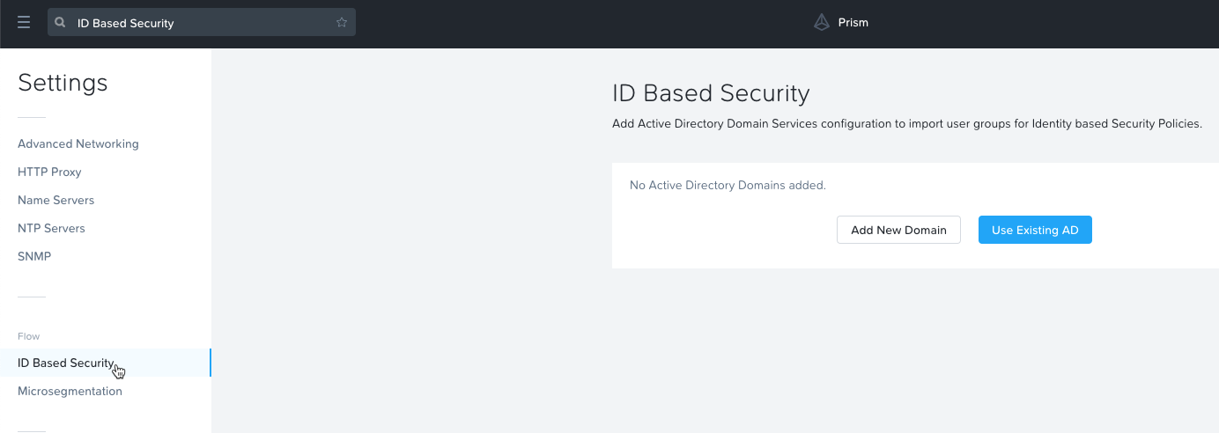

1. Select Use Existing AD
2. Select **ntnxlab** in the AD Server dropdown.

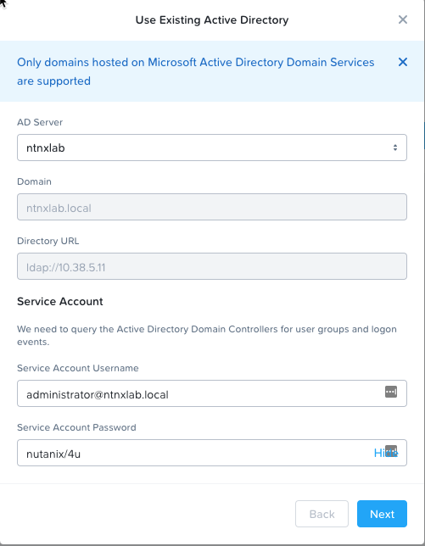

1. Enter **nutanix/4u** for the Service Account Password.

**NOTE: In a production environment Nutanix strongly recommends AGAINST using the administrator account as the service account. You should create an account for this specific purpose, and limit its scope and authority as required.**

1. Click **Next**
2. Click the **Manually Add Domain Controller** button, then click **+ Domain Controller**.

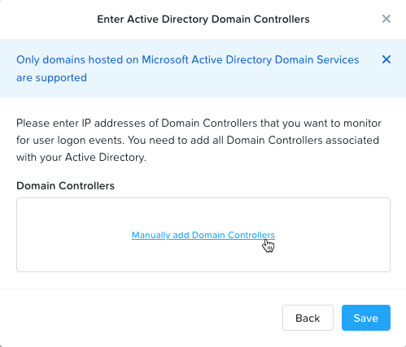

1. Enter the **IP Address** or **Host Name** of the domain controllers that you want to monitor for user logons events.

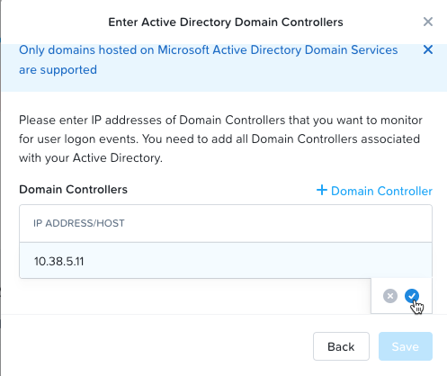

1. Confirm that the Configured Domain and Domain Controllers is as shown.

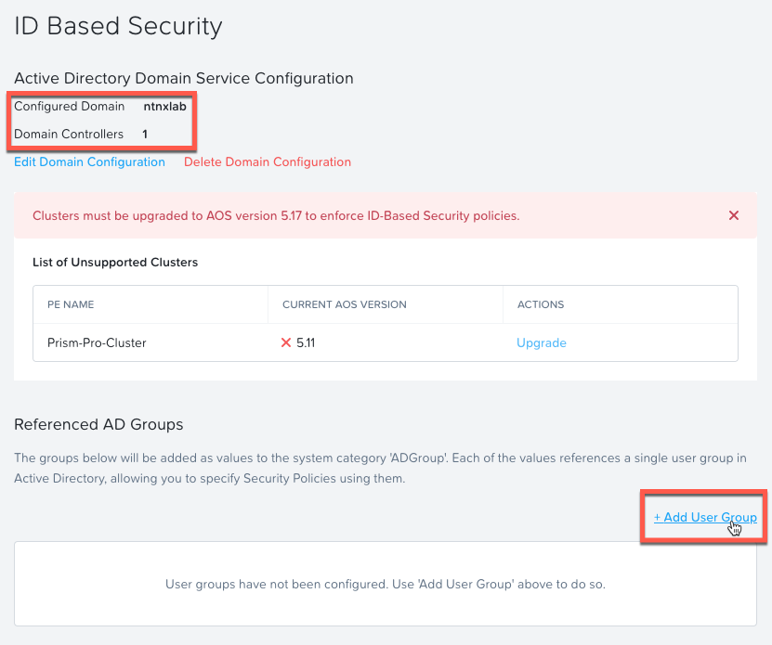

NOTE: You can safely ignore the alert relating to upgrading the Prism-Pro-Cluster.

1. Click + Add User Group
2. Click in the USR GROUP field and enter **developer**. SSP Developers should populate the field.
3. Click the blue check box to confirm and add to the list.
4. Repeat step 11, entering **consumer** in the USER GROUP field.

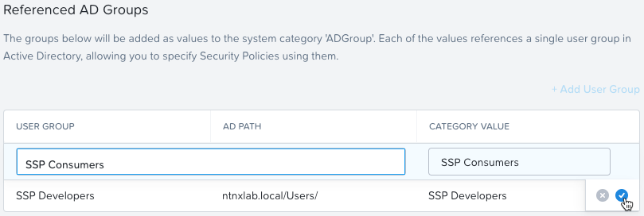

1. In Prism Central, select  > Policies > Security.



1. Delete the Fiesta Policy created in the previous lab.
2. Click **Create Security Policy > Secure VDI Groups (VDI Policy) > Create**.
3. Flow can only have a single VDI Policy so the name and purpose are prepopulated. You can specify how the policy will apply to VMs based on their name contents. This helps assure that the VM is categorized correctly. Check **Include VMs by name** and enter **VDI** in the **VM Name Contains** box.

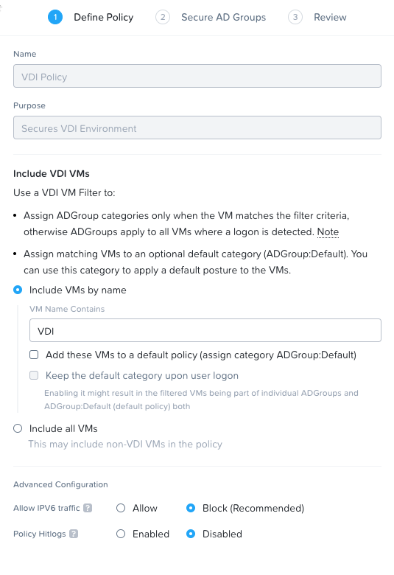

1. Click **Next**
2. In VDI ADGroups section click in the **Select an AD Group to add** box and select **SSP Consumers**.

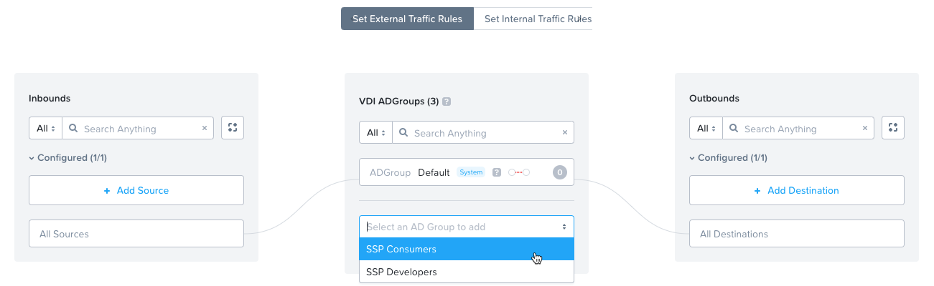

1. Repeat step 17 and select **SSP Developers**.
2. If you hover the mouse over an ADGroup just added, and click **Edit**, notice that you can prevent traffic between VMs within this group.

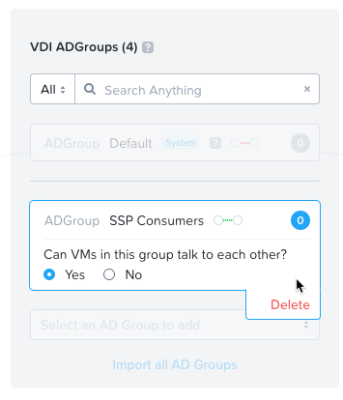

1. Since we’ll only have a single VM in this group, leave as default.
2. In the Outbounds section, click **+ Add Destination.**



1. Set **Add destination by**: to **Category**, and type **Fiesta** in the Search for a category box. This will provide all categories that include fiesta. Select **AppTier:FiestaWeb** and click Add.

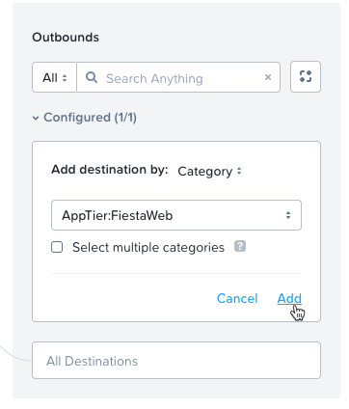

1. Repeat step 24 and add **AppTier:FiestaDB**
2. Lastly, we’ll need to assure connectivity to the AD server. Since it’s not categorized, we’ll need to add it by IP address. For this one, we need set **Add destination by:** to **Subnet/IP** and enter the IP address of your **Auto AD** VM.

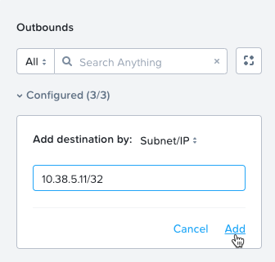

1. Click **Add**

Now that out outbound targets have been identified; we need to define the permitted traffic.

1. Click on the **AD IP** in the Outbounds section, and then the **+** icon on **SSP Consumers**

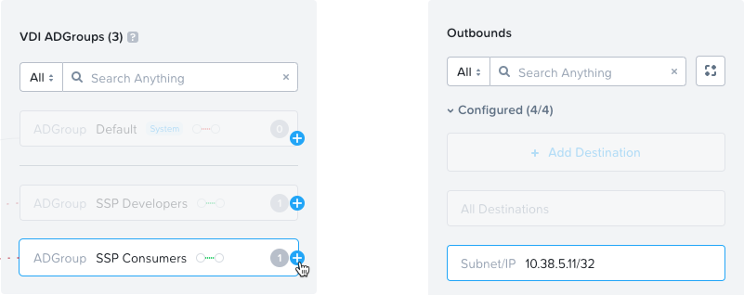

1. Leave as defaults with **Allow all traffic** selected, and click **Save.**

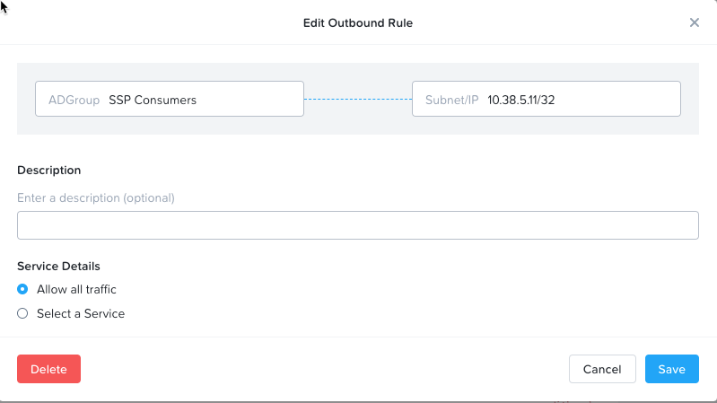

1. Repeat for **SSP Developers**. Once complete you will see each ADGroup has a line to the **AD IP**.

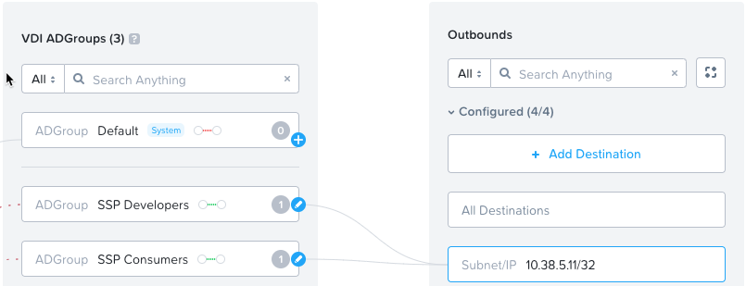

1. Under Outbounds, click on **AppTier:FiestaWeb** then click the + icon for **SSP Consumers**.
2. In the rule box, click **Select a Service** and enter **http** for the service name, and select **http** from the drop down.

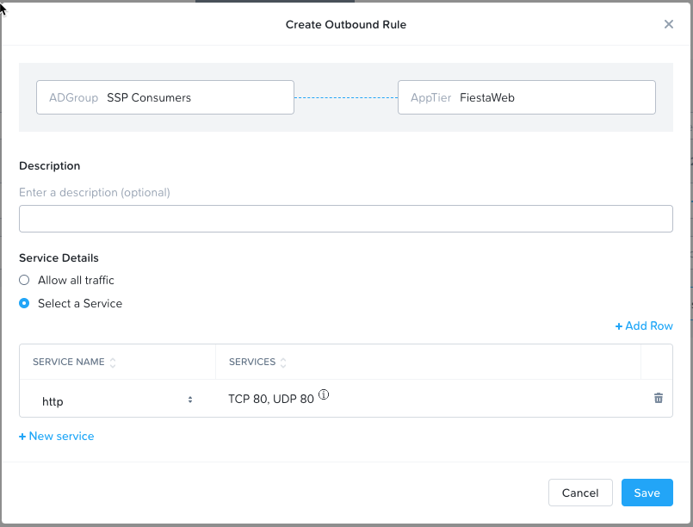

1. Click **Save**
2. Click the + icon next to **SSP Developers.**
3. Leave the defaults, **Allow all traffic.**

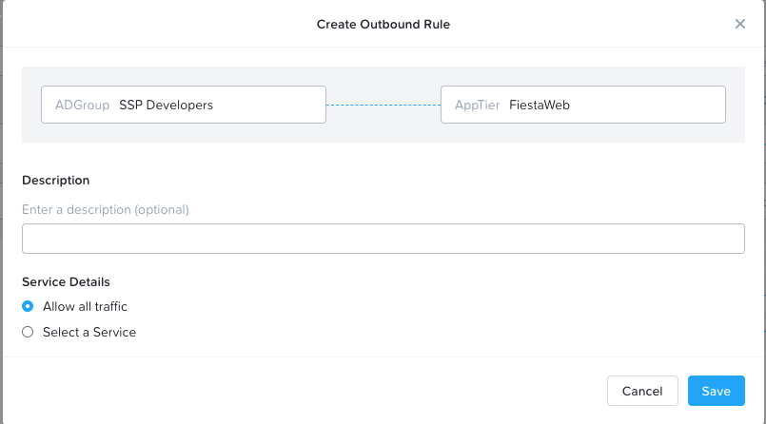

1. Click Save.
2. Repeat step 32 using **AppTier:FiestaDB** and **SSP Developers**.
3. Leave the defaults, Allow all traffic.

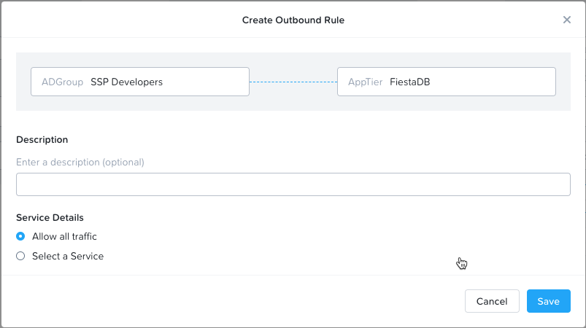

1. Click **Save**.
2. The result is both SSP Consumers and SSP Developers are permitted to **AppTier:FiestaWeb**, and only SSP Developers is permitted to **AppTier:FiestaDB**

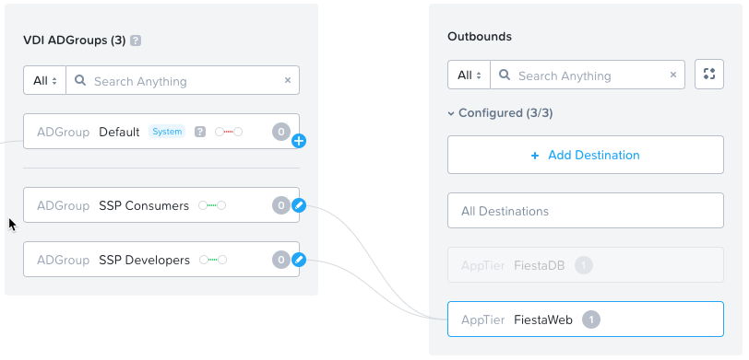

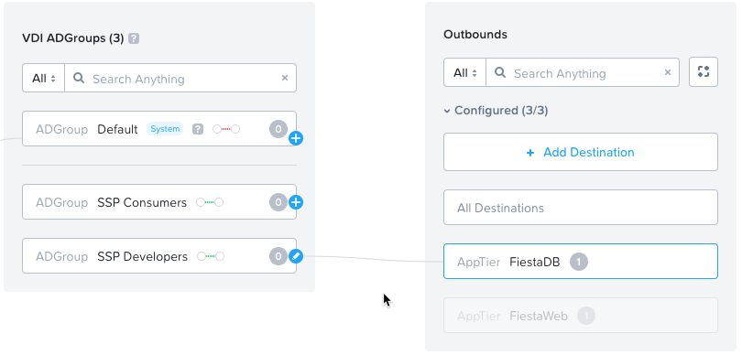

1. Click **Next**
2. Click **Save and Monitor**

Now we will test our policy using the 2 VDIClient VMs.

1. From Prism Central > Virtual Infrastructure > VMs

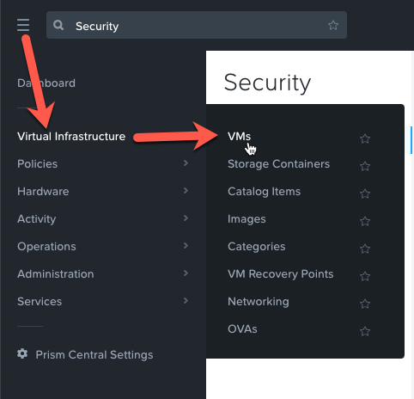

1. Click the checkbox next to **VDIClient1**, then click **Actions** > **Launch Console**.

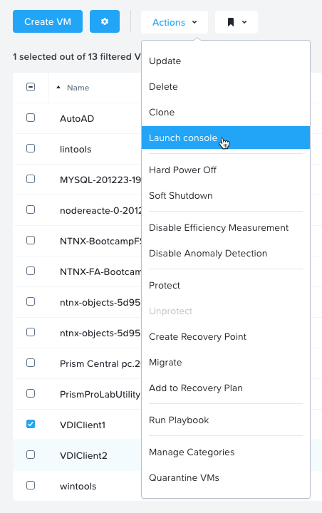

1. Repeat step 45 for **VDIClient2**.
2. By default the administrator user is logged into the VM, so click **Switch user** on each VM console.
3. On **VDIClient1** console, click on the Ctrl-Alt-Del button in the upper right corner.

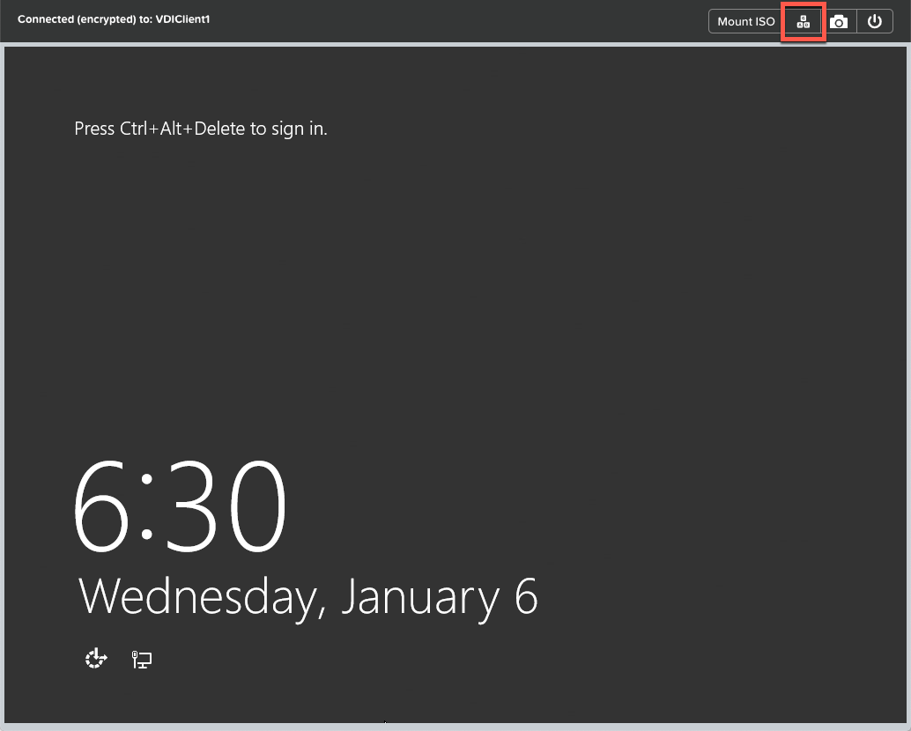

1. Click on Other user

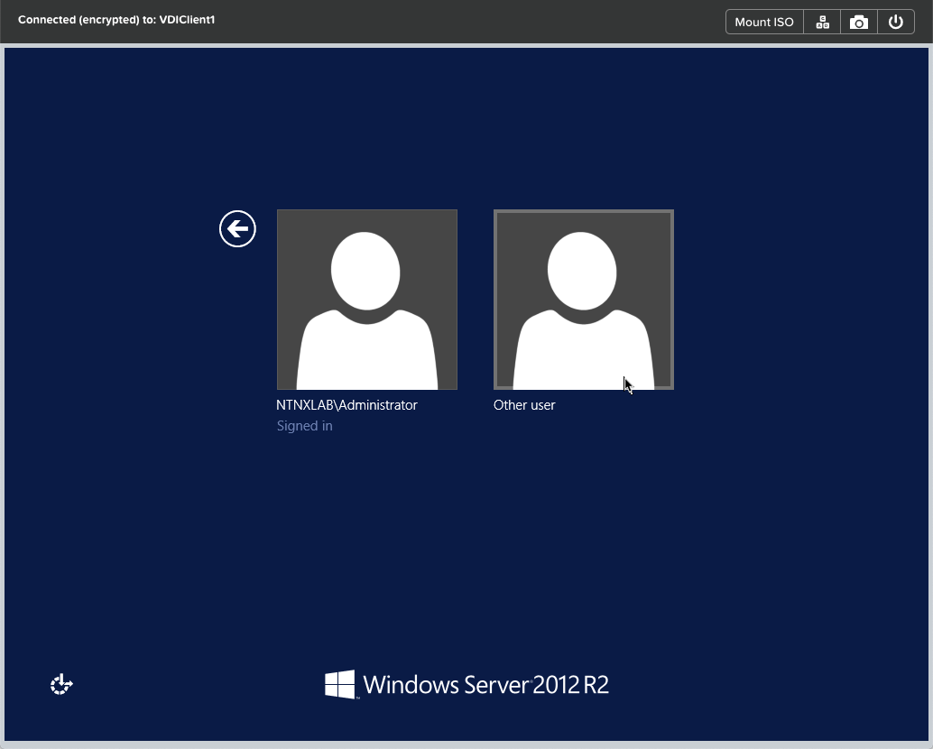

1. Enter **Consumer01** for the user and **nutanix/4u** for the password.

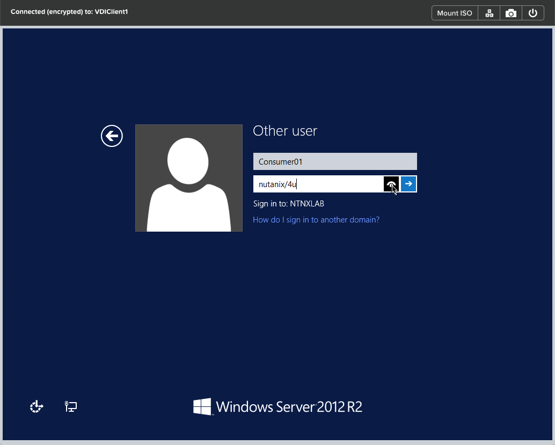

1. Repeat steps 48 to 50, with **Devuser01** for the user and **nutanix/4u** for the password.

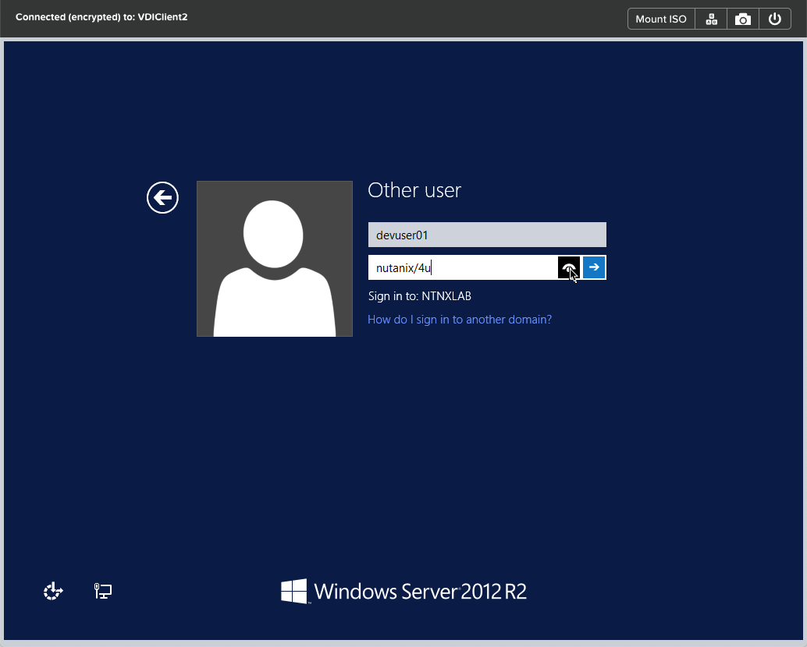

1. Once logged into *both* consoles, open Chrome and enter the IP address for the Fiesta web server – named **nodereacte-X-XXXX.** You should see the Fiesta homepage**.**

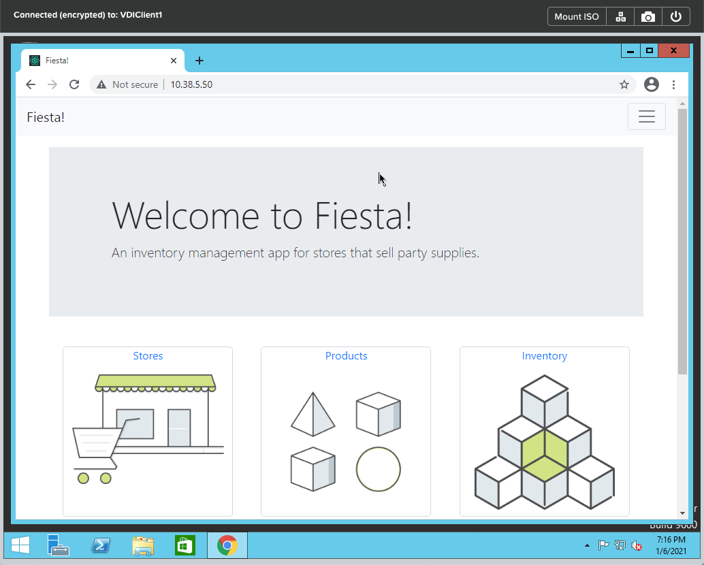

1. Now open a command prompt and ping the IP addresses Fiesta Web and Fiesta DB servers (nodereacte and MYSQL). Repeat this on *both* VDIClient VMs.

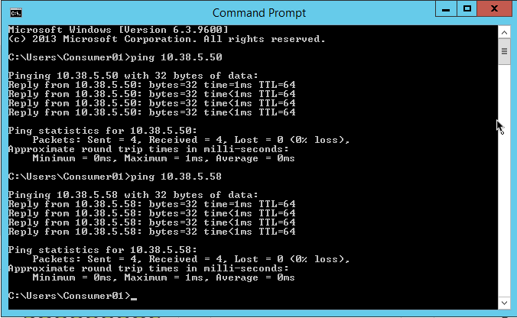 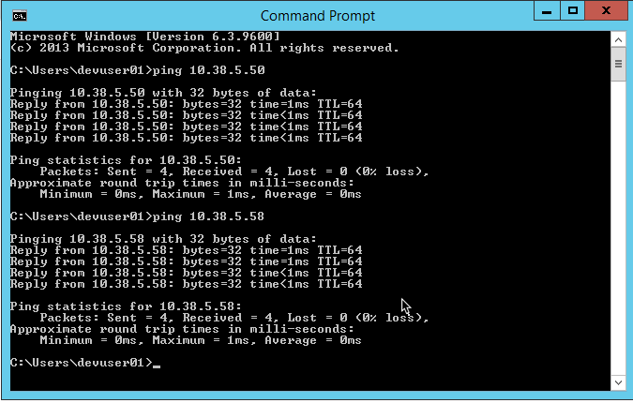

Why do the pings from VDIClient1 (Consumer01 user) succeed?

1. PC > Policies > Security
2. Click on **VDI Policy.**

Since the policy is in monitor mode, all traffic is permitted, but traffic that is not compliant with the policy is illustrated by the orange lines. In the below example, there are 68 discovered flows, which are exceptions to the configured policy.

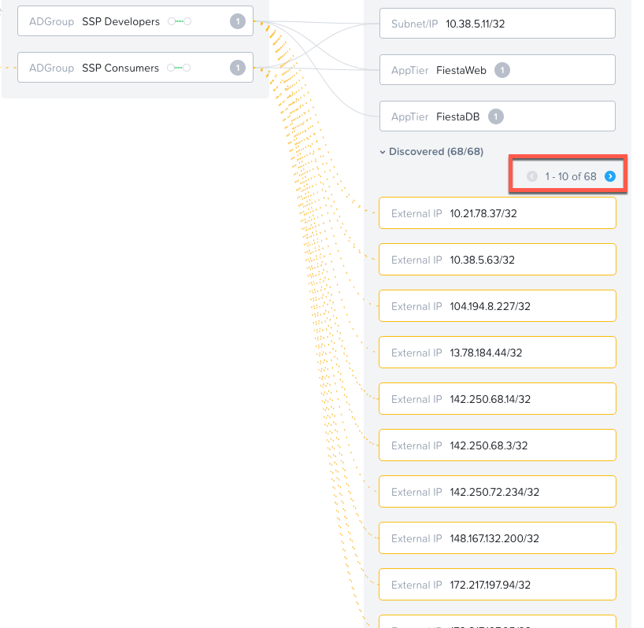

1. Click on the **blue right arrow** until you find the web or DB server.

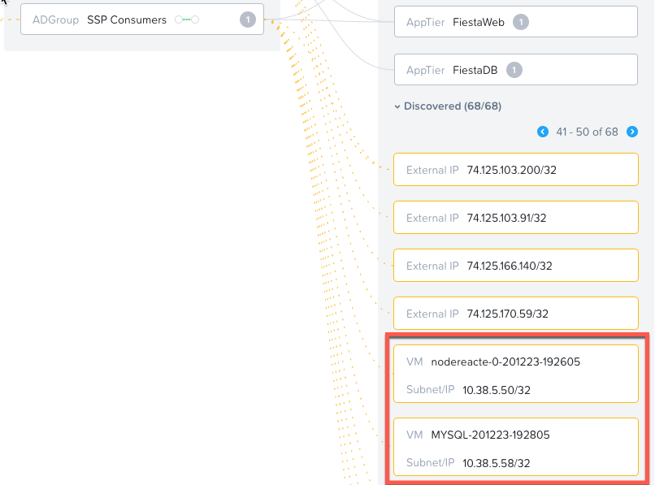

NOTE: They may not appear together, or on the same page.

1. Mouse over one of the lines running from either Fiesta server. This will provide details on the traffic that was captured.

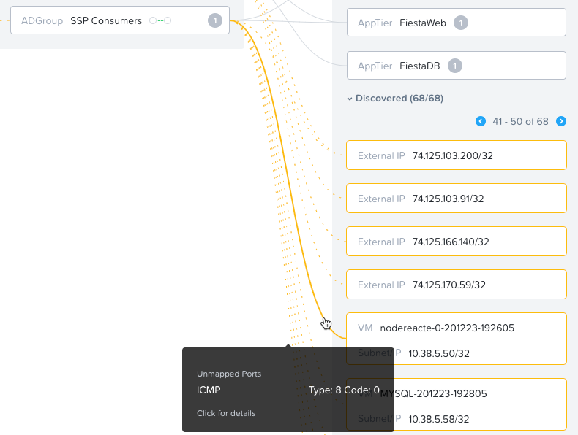

In this example, it is a ping from the VM that user Consumer01 is logged into (VDICLient1). The same would be true for the line from the MYSQL server since the configured policy is to only permit http traffic from SSP Consumers VMs to the nodereacte VM (FiestaWeb).

1. In the upper right corner, click on **Enforce**, and confirm when prompted.

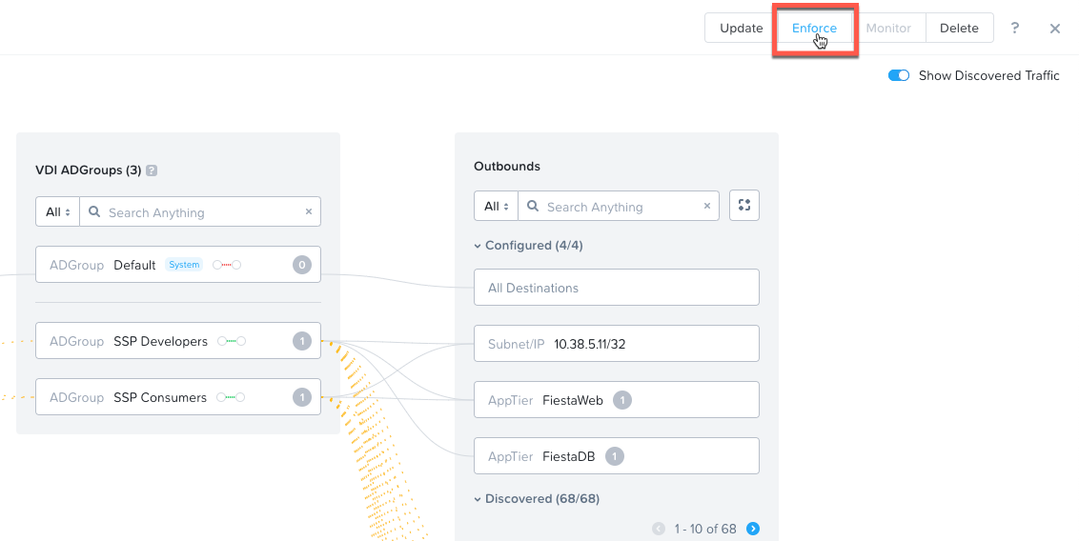

1. Click the **X** in the upper right to dismiss this window, and return to the Security Polices page.

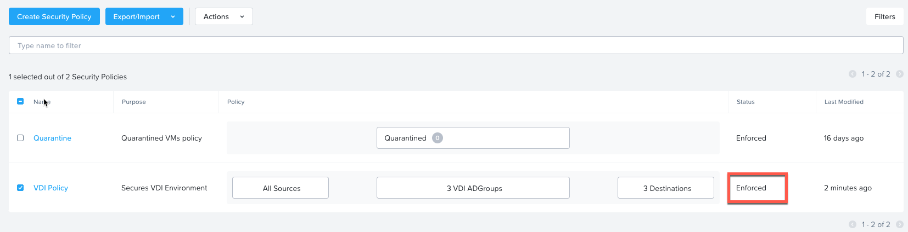

Note that the VDI Policy is now in an Enforced status.

1. Return to the **VDIClient1** VM console (you may need to close and reopen to restore the session)
2. In Chrome, refresh the Fiesta webpage, and click on Stores, Products or Inventory to be sure we still have complete http access.

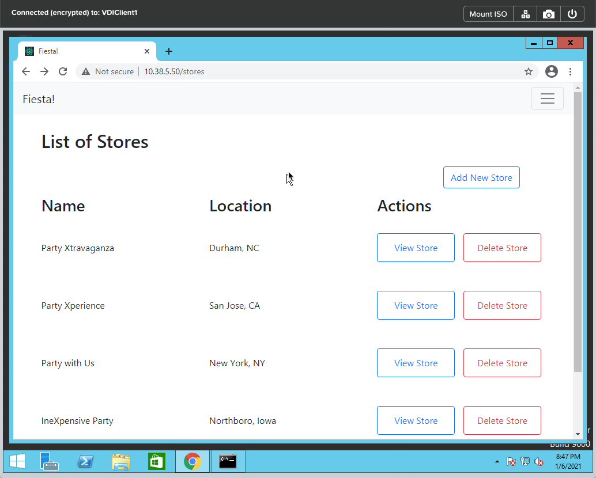

1. Switch to the command prompt and attempt the pings again. This time they will fail as the policy was changed from monitor to enforce.

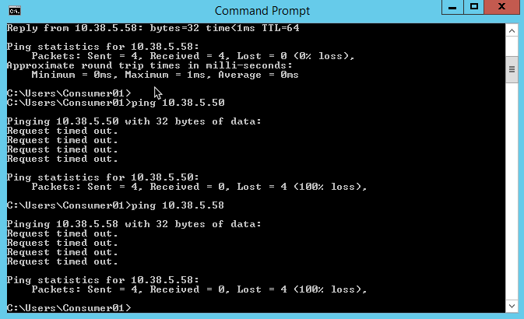

1. Return to the **VDIClient2** VM console (you may need to close and reopen to restore the session)
2. Repeat steps 61 and 62. Note that the pings succeed from VDIClient2, why is this?

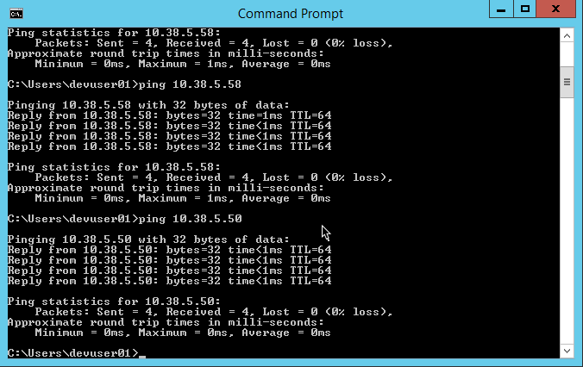

You can see how different policies were applied based on the userid that logged into that system. This completes this lab.